Mentor Mr. Trịnh Ngọc Văn

Team member

Nguyễn Bắc Giang

Nguyễn Hoàng Nam

Nguyễn Thanh Thủy

Phạm Quốc Hoàng

Nguyễn Đặng Thái Sơn

Trần Bùi Thành

restaurant chain Management

FPT APTECH - T2208E - SEMESTER 4 - TEAM 3



TABLE OF CONTENTS

I. Introduction 3

II. Objectives 4

III. Abstract 5

IV. Project Plan 5

V. Use Case 8

VI. Customer Requirement Specification. 11

VII. Database Diagram 13

VIII. Algorithms and Technology 14

IX. UI/UX User Guide Website and Mobile App 16

X. Developer’s Guide 35

XI. Acknowledgments 40

# Introduction

The **FoodSou Restaurant Chain Management Project** aims to develop a centralized management system for a restaurant chain located in Hanoi. This system will include both web and mobile platforms, streamlining operational processes, order management, delivery services, and customer experience.

With chain management capabilities, the system will assist managers in monitoring each branch in detail, from updating stock status and overseeing service quality to managing personnel. The **inner-city delivery feature** will enable real-time order tracking, efficient management of delivery staff, and order status notifications for customers.

The system will support the following key features:

* **Order Management:** Enables quick and efficient tracking and processing of customer orders.
* **Branch Management:** Allows managers to track revenue, costs, and operational efficiency of each branch.
* **Inner-city Delivery Service:** Delivery services are managed by in-house delivery staff, ensuring quality and timely delivery.
* **Customer Interaction:** The app will enable customers to book tables, order online, and track order status, providing a convenient and seamless experience.

The restaurant chain management system will optimize operational efficiency, reduce errors, enhance customer experience, and bring consistency to managing the restaurant chain.

# Objectives

The primary objectives of the **FoodSou Restaurant Chain Management Project** are to build a robust and user-friendly system that enhances operational efficiency, improves customer satisfaction, and supports scalable growth. The key objectives include:

1. **Streamline Operations Across Branches**

Implement centralized control for all branches, enabling real-time monitoring and standardized processes across the chain to ensure consistency and quality.

1. **Enhance Order and Delivery Management**

Provide a seamless order processing and delivery system with real-time tracking, order status updates, and optimized delivery routes, improving the efficiency of in-house delivery services.

1. **Improve Customer Experience**

Create a user-friendly platform for customers to place orders, track delivery status, and interact with each branch conveniently. The system should provide a smooth experience that enhances customer loyalty and retention.

1. **Data-driven Insights for Better Decision-making**

Enable data collection and analytics for key performance metrics such as sales, customer feedback, and delivery times. These insights will assist managers in making informed decisions to improve service quality and branch performance.

1. **Optimize Resource Allocation**

Implement features to track and manage inventory, workforce, and financial resources effectively, reducing wastage and ensuring resource availability across branches.

1. **Scalable Design for Future Expansion**

Design the system to support potential future expansion, allowing for new branches or cities to be added with minimal setup. The system should be flexible and scalable to adapt to the company’s growth strategy.

By achieving these objectives, the **FoodSou Restaurant Chain Management Project** aims to establish a competitive advantage, ensuring high-quality service, operational excellence, and a seamless experience for both customers and staff across all locations.

# Abstract

The **FoodSou Restaurant Chain Management Project** is designed to create a comprehensive web and mobile application system to streamline the management of a restaurant chain based in Hanoi. By centralizing the operations, order processing, and delivery services within a single platform, this project aims to improve operational efficiency, ensure consistency across branches, and enhance customer experience.

This system will enable real-time monitoring and control over multiple branches, providing tools for managers to track inventory, sales, and employee performance seamlessly. Integrated delivery services allow for real-time order tracking and effective management of in-house delivery personnel, ensuring timely and reliable service within Hanoi's urban area.

Furthermore, the platform will offer customers a convenient interface for ordering, booking, and receiving order updates, which not only improves satisfaction but also builds loyalty. Through analytics and data-driven insights, the project will empower decision-makers to optimize resource allocation, predict demand, and identify areas for operational improvement.

With scalability at its core, the **FoodSou Restaurant Chain Management Project** is built to support the future expansion of the chain, ensuring that additional branches can be smoothly integrated. This project aims to position the restaurant chain as a leader in service quality, operational excellence, and customer-centric solutions in Hanoi.

# Project Plan

**• Determine the project goals to be achieved - Project Goal.**

The project aims to automate and optimize the management of a restaurant chain in Hanoi, improving efficiency in operations, order processing, and delivery services within Hanoi's urban area.

**• Determine project deliverable time – Project Deliverable.**

* **Project Start Date:** October 4, 2024
* **Project Evaluation:** November 14, 2024
* **Project Submission Date:** November 28, 2024

**• Determine the project roadmap - Project Schedule.**

1. **Introduction**
   * Summarize the challenges of managing a multi-branch restaurant chain, difficulties in handling delivery logistics, and propose ideas for a centralized management system to streamline operations and improve service quality.
2. **Plan**
   * Develop a project implementation plan divided into **4 sprints**, each lasting **1 week**.
     + **Sprint 1:** Set up foundational architecture, define main modules, and establish database structure.
     + **Sprint 2:** Implement key features for branch management and order processing.
     + **Sprint 3:** Integrate delivery management feature, ensuring real-time order tracking and customer notifications.
     + **Sprint 4:** Finalize user interface, optimize performance, and conduct testing for quality assurance.
   * **Task Assignment:** Assign tasks to team members, specifying responsibilities, deadlines, and weekly progress targets.
3. **Analysis - Design**
   * Describe the problem with diagrams:
     + **Stakeholders:** Define roles for each component within the system, including permissions based on roles.
     + **Use-case Diagrams:** Outline user interactions with each major feature.
     + **Flowchart:** Illustrate the flow of order processing, from placement to delivery.
     + **Process Diagram (sequence):** Show sequences of core processes such as order handling and delivery dispatch.
     + **ERD (Entity-Relationship Diagram):** Define entities such as Branch, Order, Delivery, Customer, etc.
4. **Supporting Plans - Supporting Plans**
   * **Human Resource Plan:** Define roles (e.g., Project Manager, Developer, UI/UX Designer, Quality Assurance), and assign specific tasks and workloads.
   * **Communication Plan:** Establish channels for sharing updates and documentation with team members and stakeholders.
   * **Risk Management Plan:** Identify potential risks (e.g., underestimating time, incomplete tasks, or difficulties in workload distribution) and define preventive or corrective actions.
5. **Project Implementation**
   * **Task Sheet:** List detailed tasks for each function to complete the above flows. Include fields for **Function name**, **Description**, **Input**, **Output**.
   * **Testcase Documentation:** Add a **Success/Fail** column to the task sheet to report items that function correctly or require revision.
6. **Technology used in the project**
   * Specify the **algorithms** and **technologies** for database management, backend, and frontend development.
   * Outline requirements for **server configuration** and **deployment technology** (e.g., cloud services, hosting requirements).
7. **Results**
   * Describe the main features of the system with screenshots, showcasing key functionalities like order processing, delivery tracking, and customer management.
8. **Conclusion & Development Direction**
   * Discuss achievements, unresolved aspects, challenges encountered, and future development directions for the project, such as expanding to more cities or adding advanced analytics for better business insights.

# Use Case

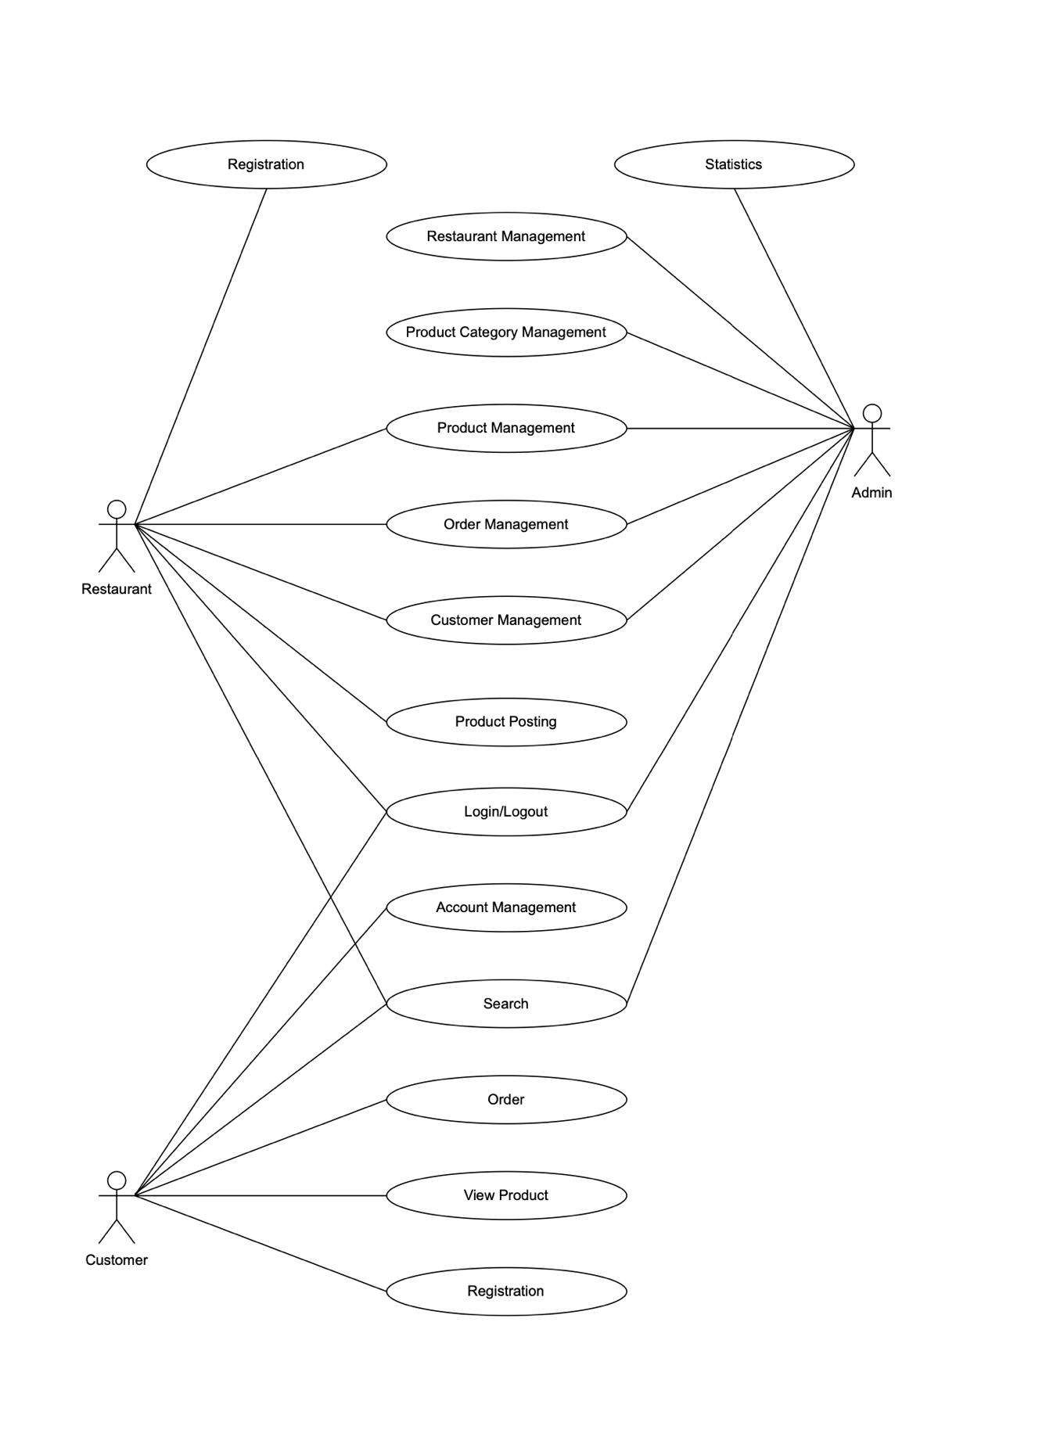

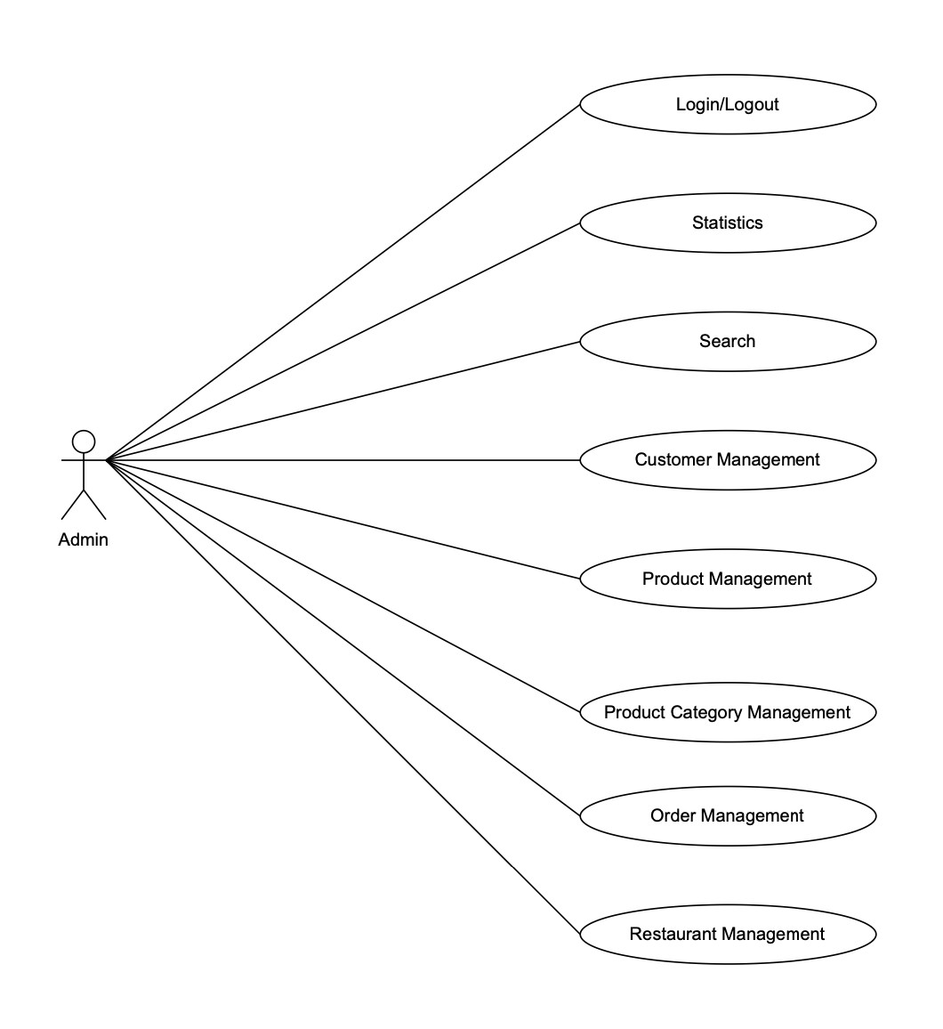

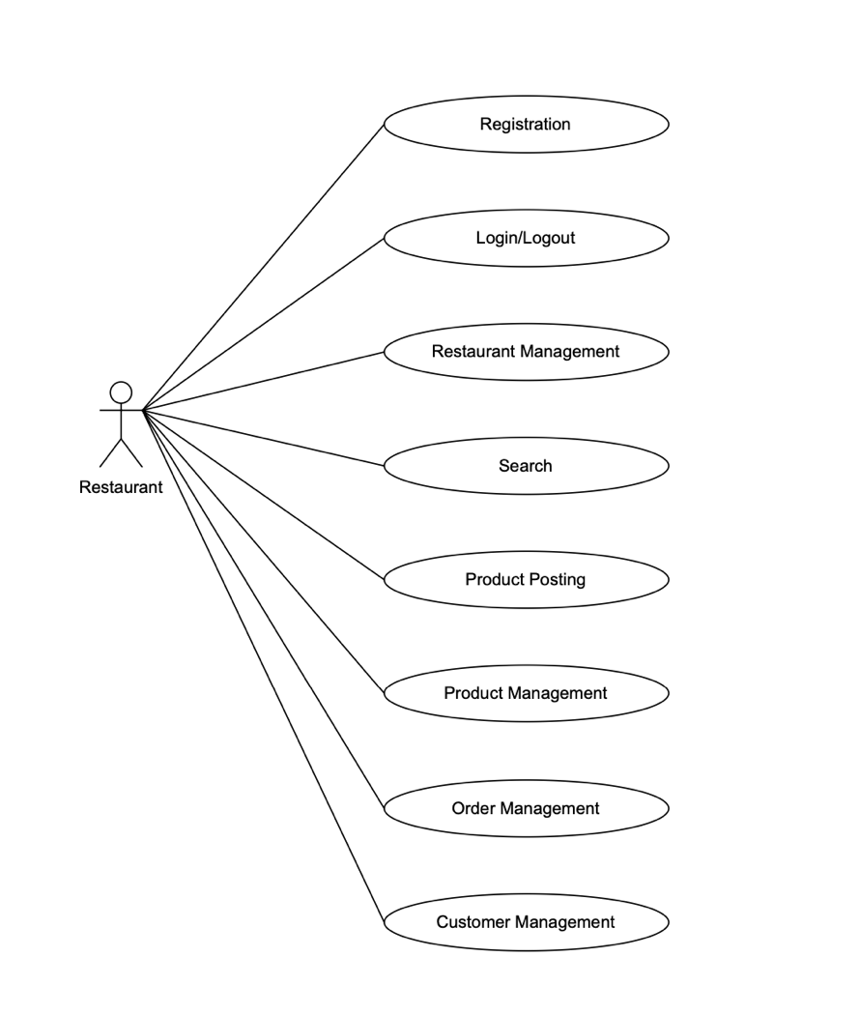

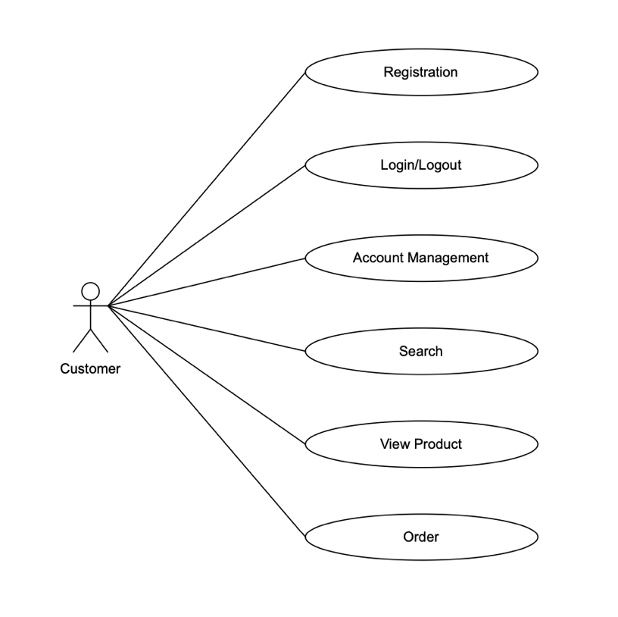

# Customer Requirement Specification.

There will be 3 types of users

* Guest
* Customer
* Admin

1. Guest

Guest users will be able to browse website, read about the information and see the products. But guest users will not be able to do shopping.

1. Customer
   * Register with the system
   * Name
   * E-Mail
   * Address
   * Phone Number
   * Customer can login with email and password.
   * He can change the password.
   * Can purchase the food online: For purchasing the food online, he has to choose the menu and fill in the form with delivery information. On successful payment, an order will be prepared and customer can check the order status.
   * Can book for a table: For booking table, he has to fill in the form with the customer information and wait for the call from the employee for confirm the information.
2. Admin

* Employee will be admin who can login with admin email and password.
* He can perform all the admin functions as public a new restaurant, create the restaurant menu, add restaurant events, check the restaurant income chart, check the customer order status, confirm booking table information.
* Following reports needs to be generated
  + Monthly sell
  + Orders by category

1. The site should have menu categorising required functionalities

* About us
* News
* Contact us
* Booking table

1. There should be a categorized menu.
2. Data should be properly paginated while showing the products.
3. The site should have a professional look and feel.

# Database Diagram

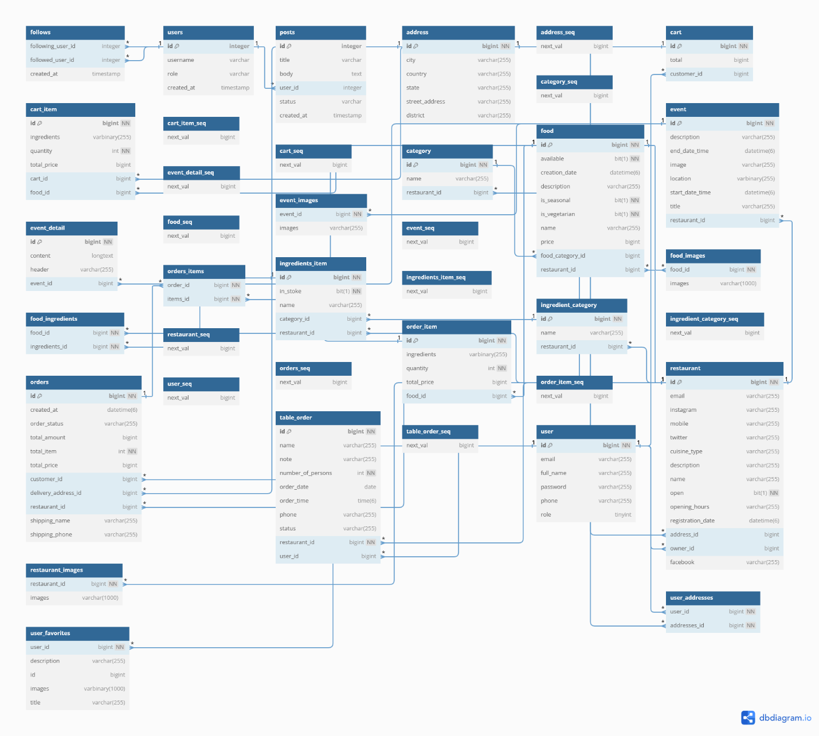

* The diagram provides a comprehensive view of a restaurant management system, showcasing how users interact with restaurants and food items.
* It highlights essential operations such as placing orders, writing reviews, and managing favorites, creating a user-centric experience.

This structured layout allows for efficient data management and retrieval, supporting various functionalities within the application.

**Overview of the Database Diagram**

1. **Tables**:
   * **users**: Stores user information, including ID, name, email, and passwords.
   * **restaurants**: Contains details about restaurants, including their names, locations, and other attributes.
   * **address**: Manages address details associated with users and restaurants.
   * **category**: Defines various categories for restaurants or food items.
   * **food**: Represents individual food items available at restaurants, linking to categories.
   * **ingredients**: Lists ingredients used in food items.
   * **menu**: Connects food items with restaurants, indicating availability and pricing.
   * **orders**: Tracks user orders, linking to users and restaurants.
   * **order_items**: Details specific items within an order, linking food items to orders.
   * **reviews**: Manages user reviews of restaurants.
   * **favorites**: Tracks users' favorite restaurants.
   * **images**: Stores images related to food and restaurants.

# Algorithms and Technology

1. Hashing

These mathematical functions take input, called a key, and use it to calculate a fixed-size character string called a hash value. Hashing algorithms transform random-sized data into information that is of a fixed-length value. We use hashing algorithms to perform storage, retrieval, or comparisons in cases where we need to:

* Hash passwords
* Perform data integrity verification

1. Front-end ReactJS

React JS is an open-source JavaScript library created by Facebook with the aim of building interactive user interfaces for software applications. It is quickly growing to become one of the most widely used languages by developers across the globe. React allows developers to create user-friendly components. Since its creation in 2011, it has remained a top front-end development platform for developers.

Why ReactJS ?

* Easy, Flexible and Simple to Use
* React has a rich library
* React Native transformed mobile development
* React allows for scalability
* React enables easy testing

1. Back-end Java

Apache Maven is an open-source build automation and project management tool widely used for Java applications. As a build automation tool, it automates the source code compilation and dependency management, assembles binary codes into packages, and executes test scripts.

Spring Framework (Spring) is an open source software development framework that provides infrastructure support for building Java-based applications on any deployment platform.

1. Database MySQL Server

MySQL Server is an open-source relational database management system. MySQL is a powerful and versatile database management system that has become a standard in the industry for managing data. Its combination of speed, reliability, and ease of use makes it a popular choice for developers and organizations worldwide. Whether you are building a simple website or a complex application, MySQL provides the tools and capabilities needed to manage your data effectively.

1. Software

* Visual Studio Code
* MySQL
* IntelliJ
* Android Studio
* Docker
* Postman
* Jira

Jira is an agile project management tool that supports any agile methodology, be it scrum, kanban, or your own unique flavor. From agile boards, backlogs, roadmaps, reports, to integrations and add-ons you can plan, track, and manage all your agile software development projects from a single tool.

# UI/UX User Guide Website and Mobile App

## **WEBSITE UI/UX**

User open browser and go to the website:

<https://foodsou.store/>

Guests will be able to browse website, read about the information and see the restaurants. But guests will not be able to do shopping.

1. Home Page

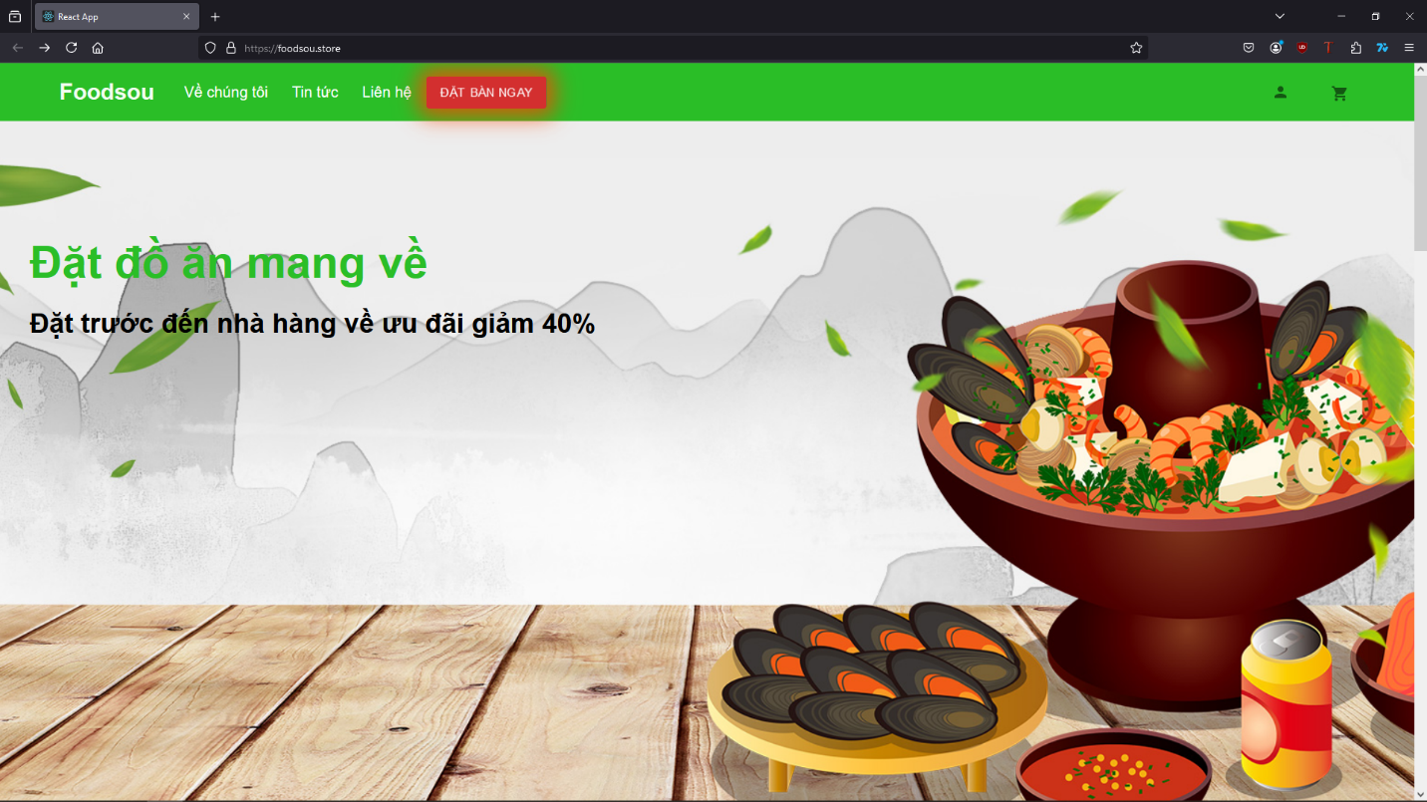

When browsing home page, people can see the information like events, restaurant list and click on restaurant to see the menu of the restaurant.

1. About Us

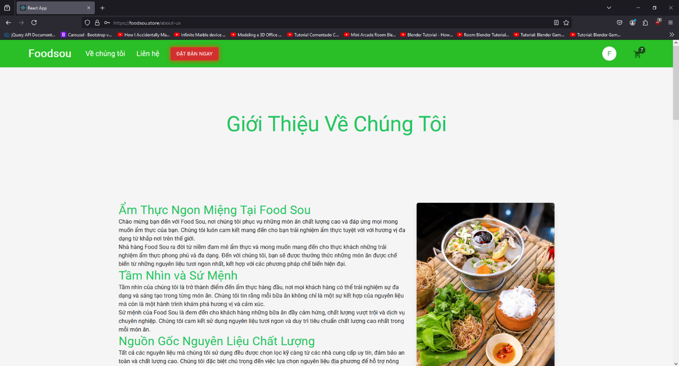

1. Contact Us

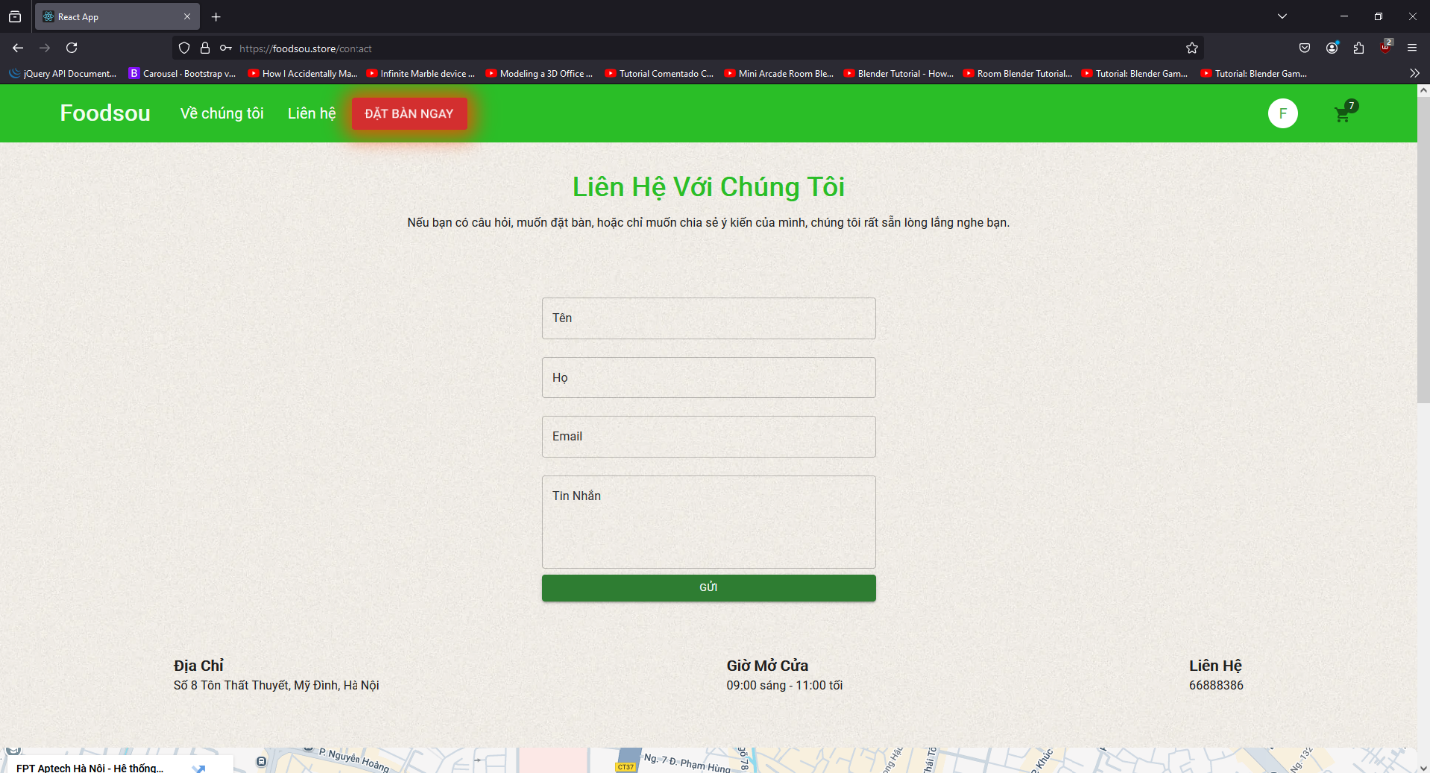

## **CUSTOMER GUIDE**

Guest can click on “Profile” icon on the navigation bar to make an account and become a customer to start buying products.

1. Sign Up / Log in

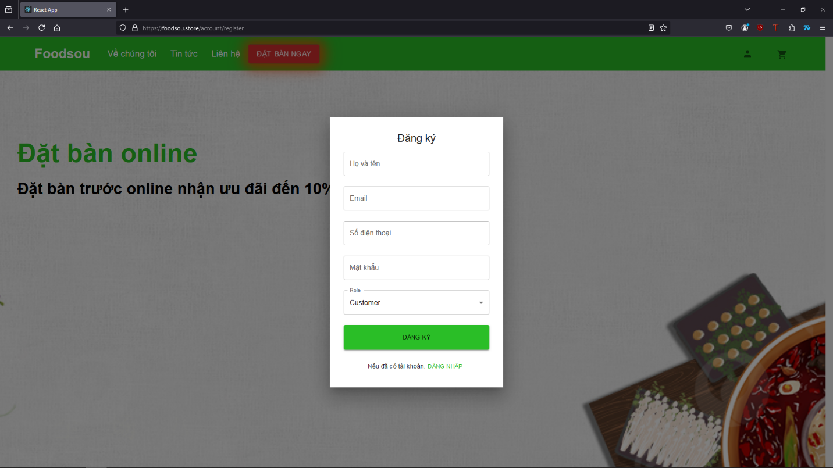

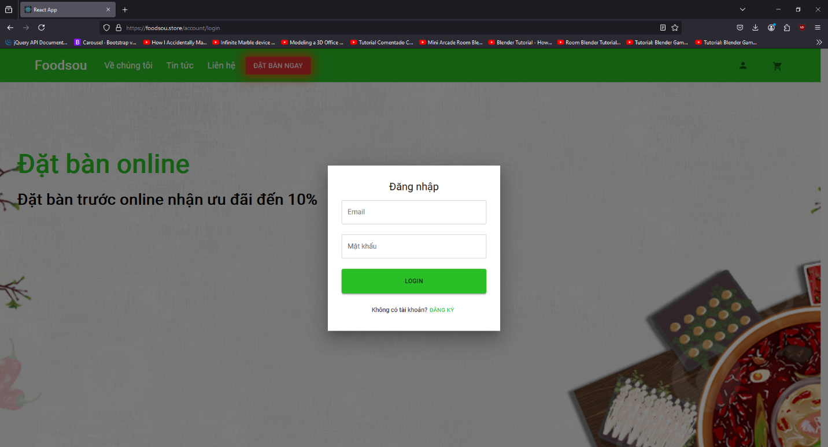

1. Booking table

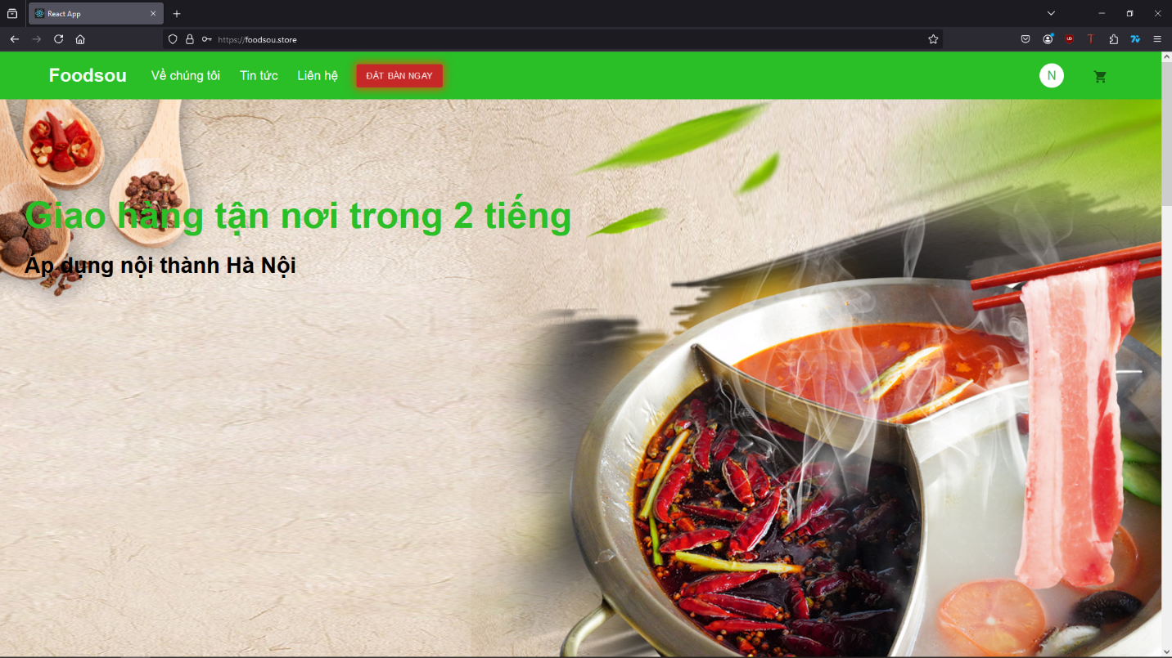

Customer can book a table by click the button on the navigation bar. Then a form will show up for customer to fill in.

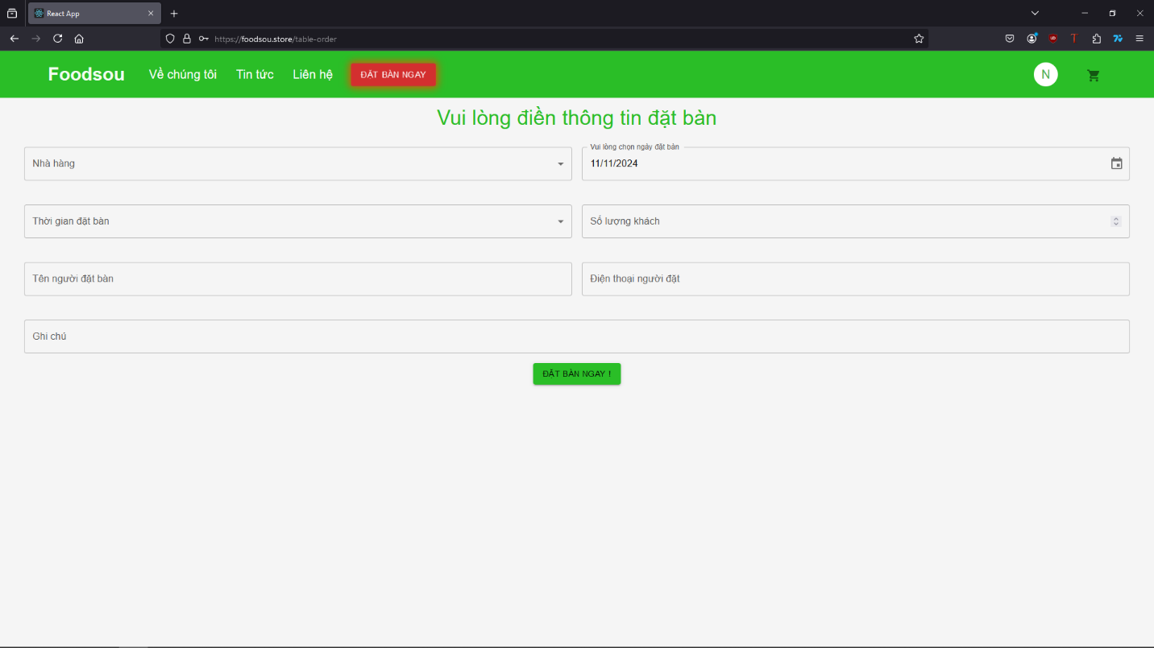

1. Make an order

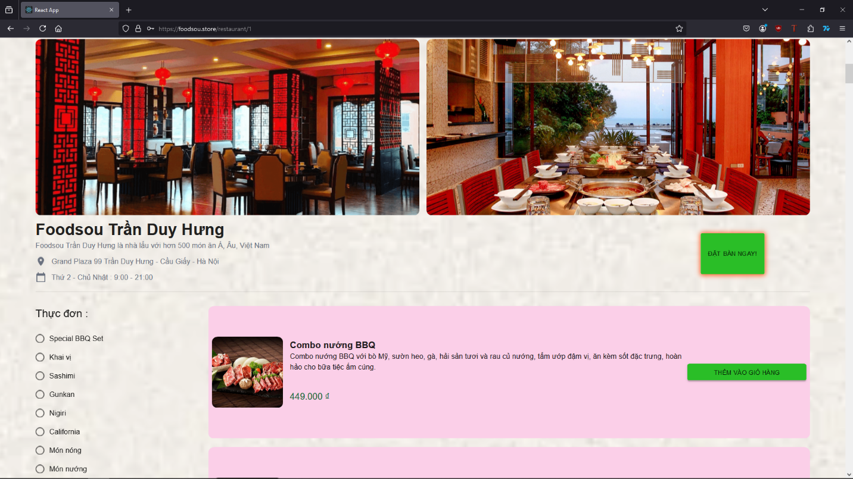

Choose the restaurant which you want to order food from on the home page then you can see the restaurant detail information with the menu and category of the menu. Add the item you want by press “Add to cart” next to the item.

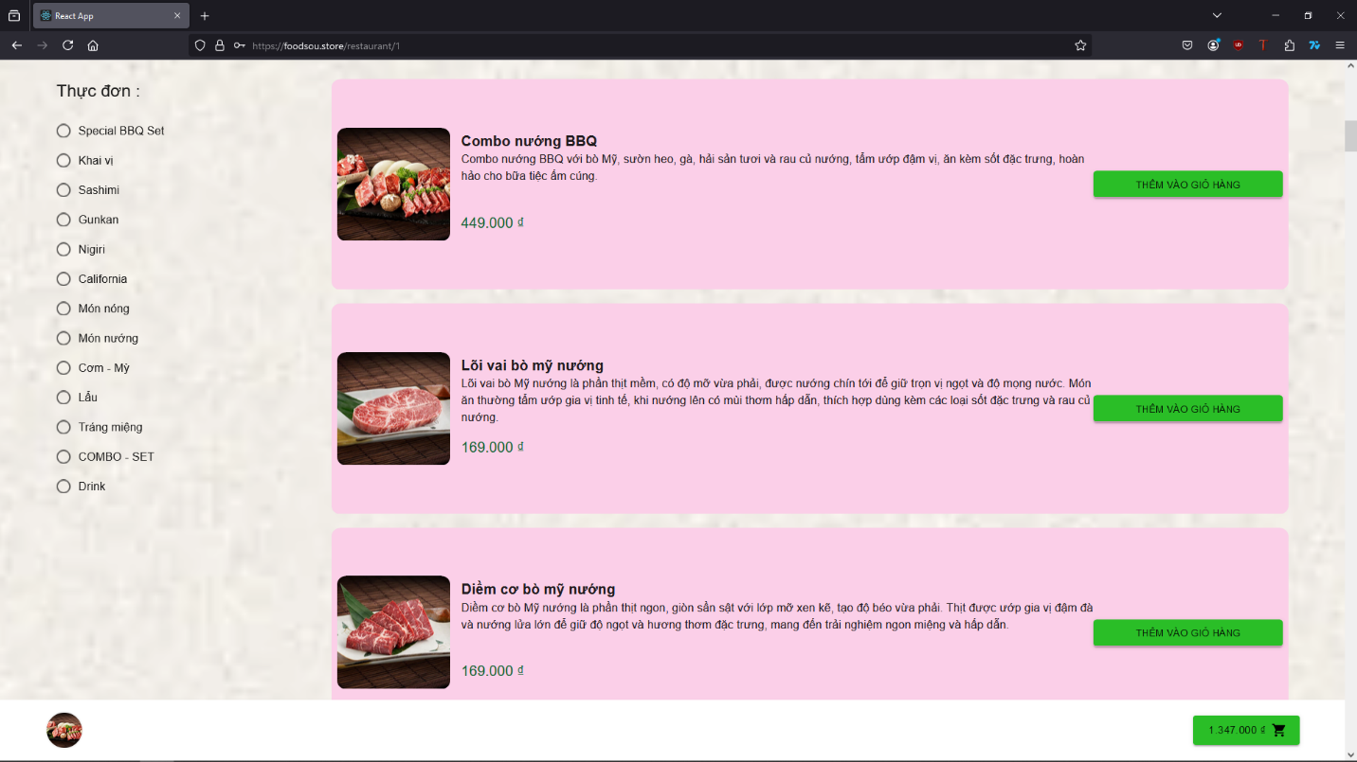

When customer ready to check out, simply click on the “Cart” icon below to go to check out page

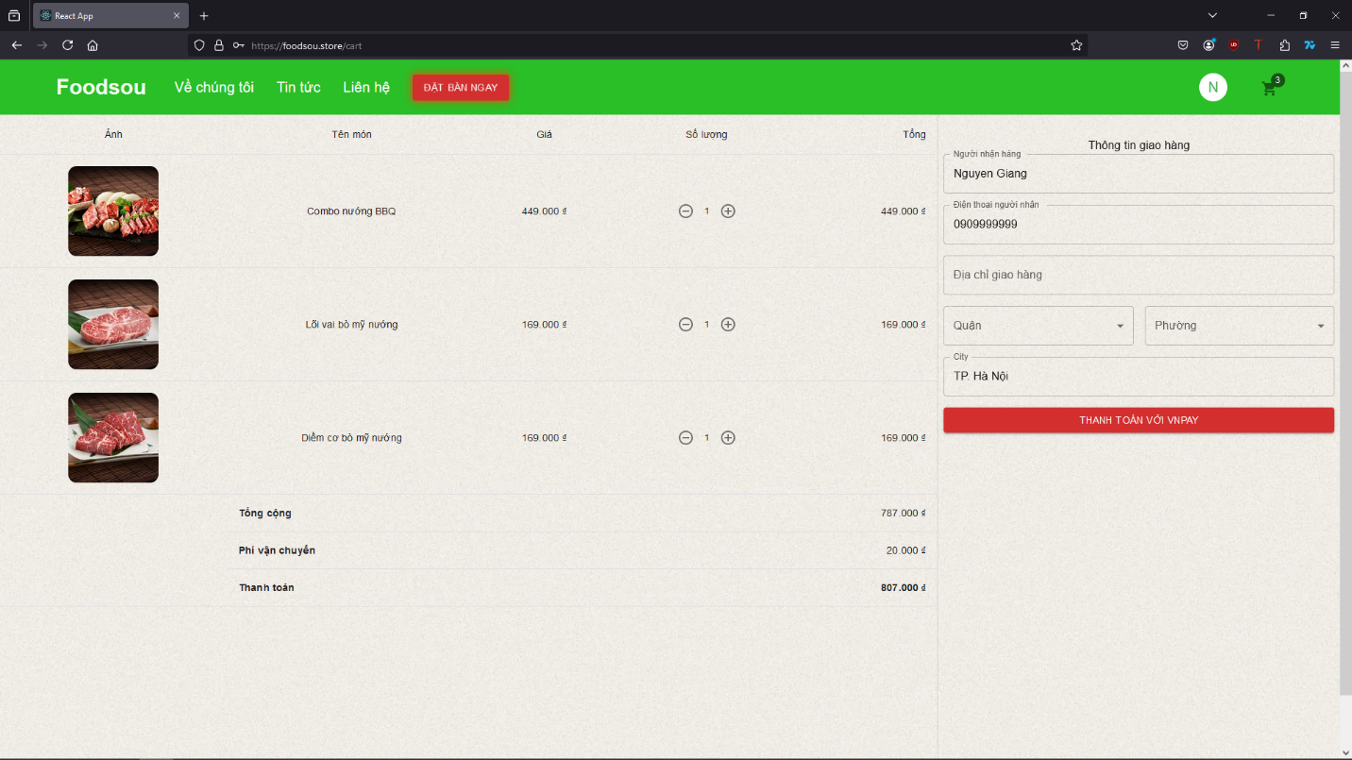

Customer need to fill in form for the delivery then click “Pay now” to go to the payment page and pay for the order.

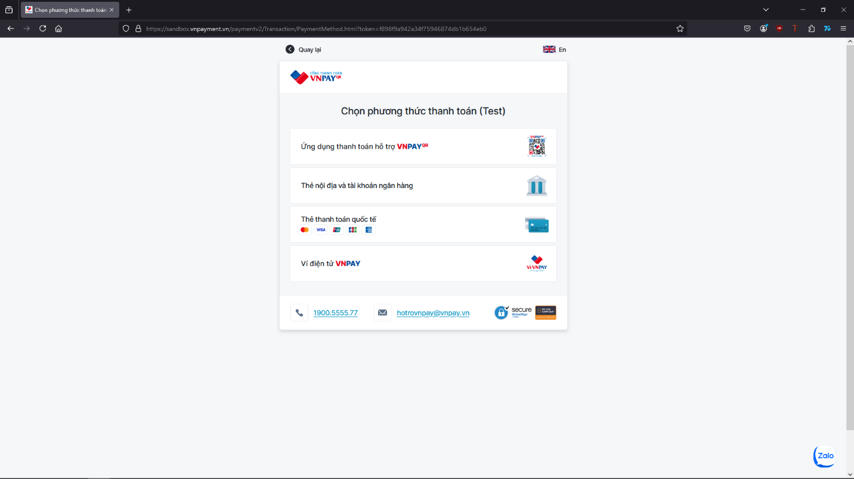

1. Profile page

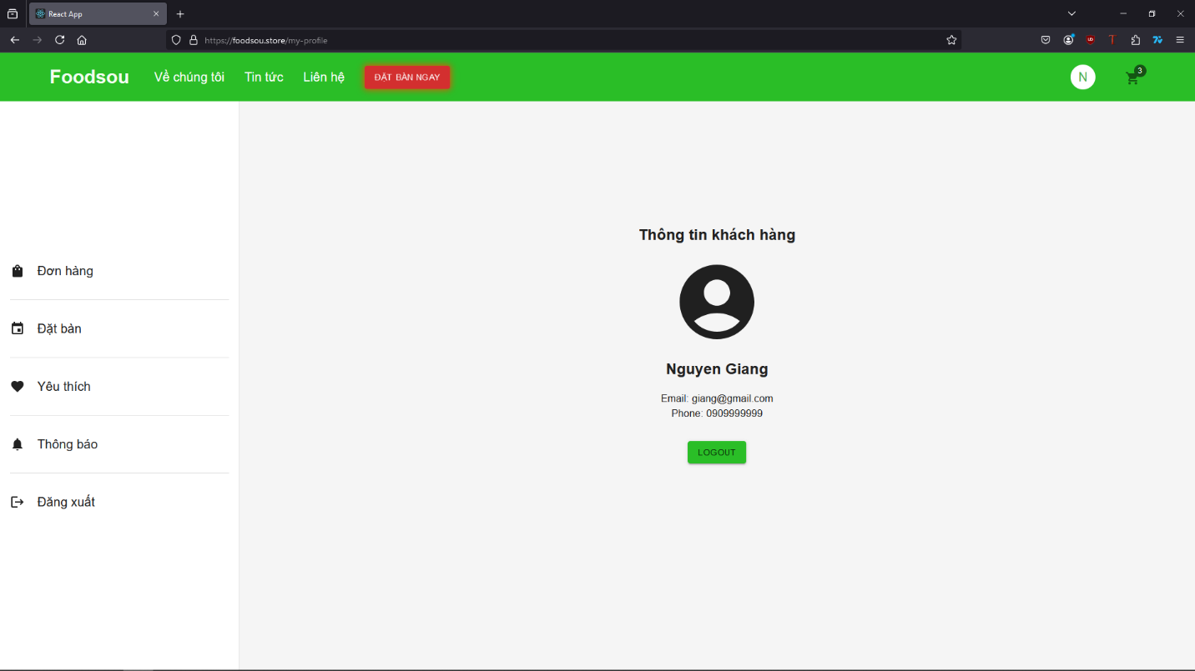

Customer’s information will show on the list. Customer can check their order status, order history, booking table status, favorite restaurant, favorite food, notification.

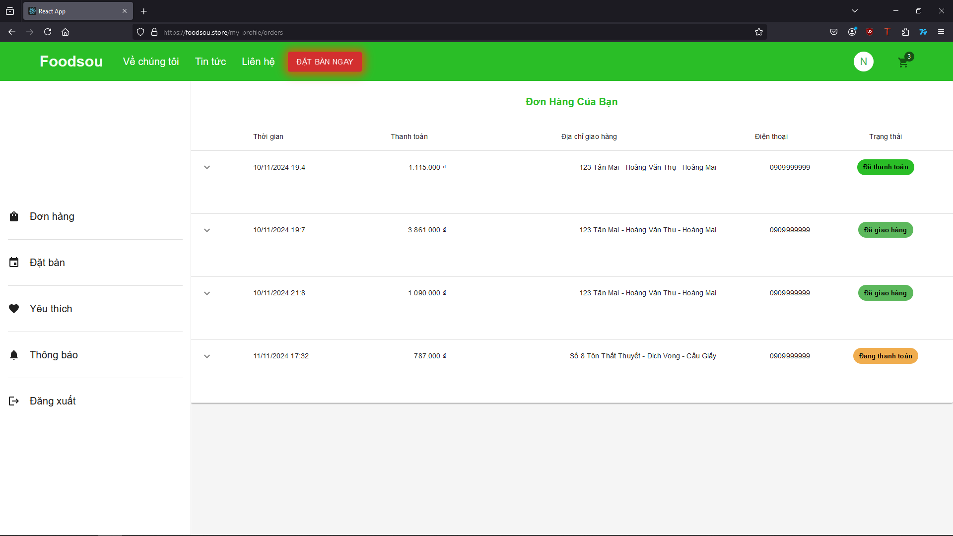

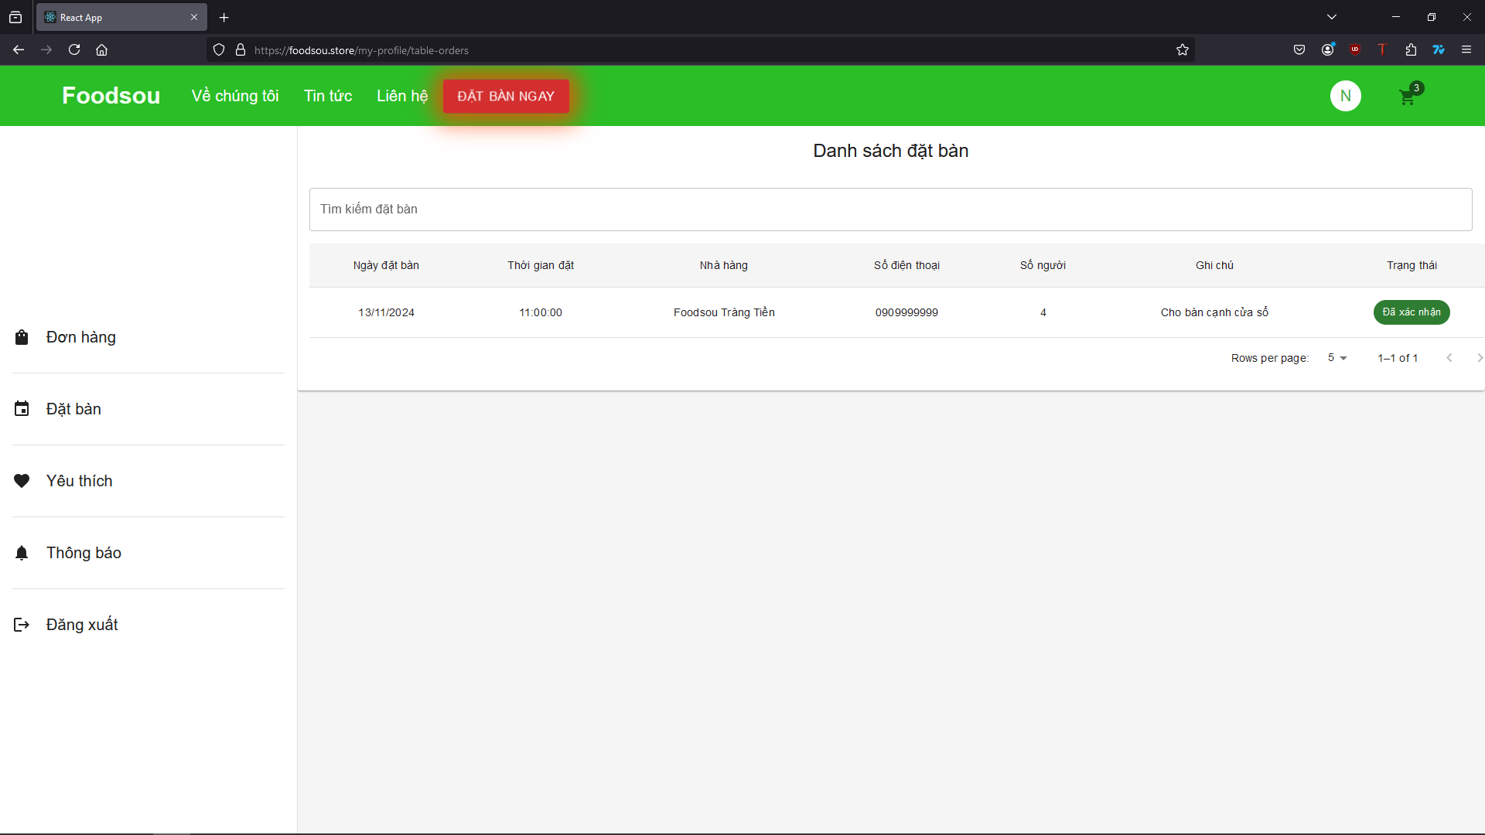

## **ADMIN GUIDE**

* Employee will be admin who can login with admin email and password.
* He can perform all the admin functions as add a new restaurant, make the restaurant menu, add restaurant events, check the restaurant income chart, check the customer order status, check booking table information.
* Following reports needs to be generated
  + Monthly sell
  + Order category

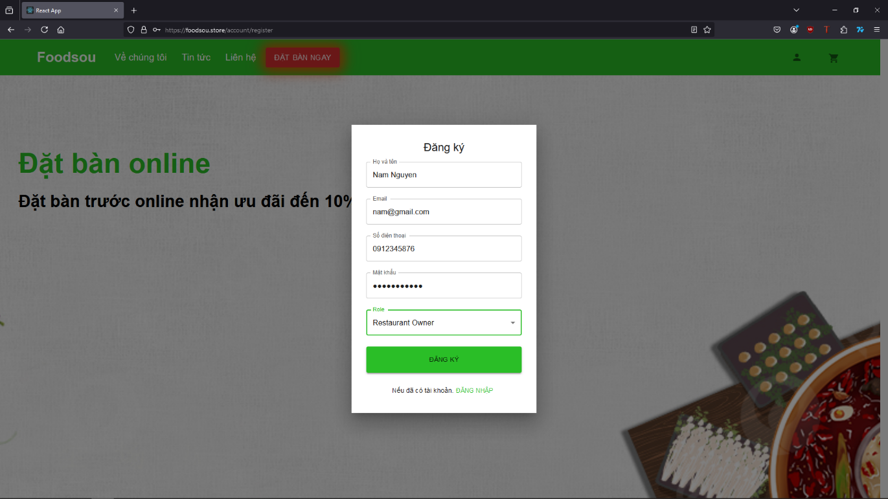

Admin has a different interface with Dashboard and charts with detail numbers.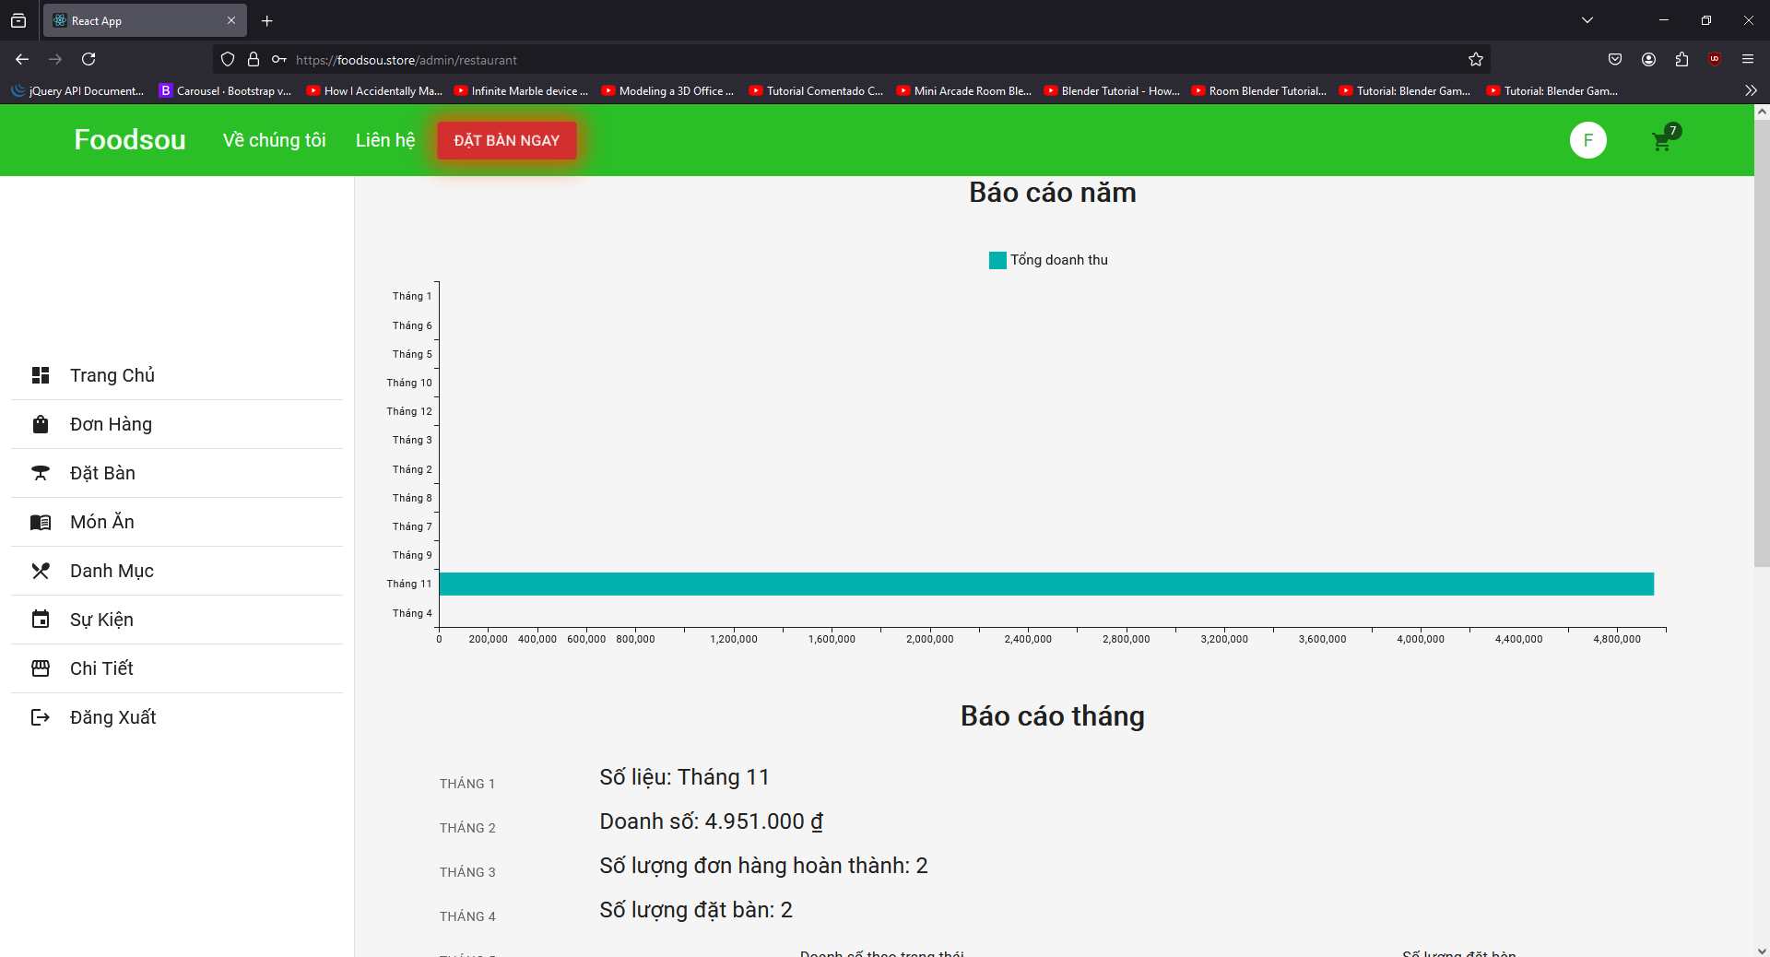

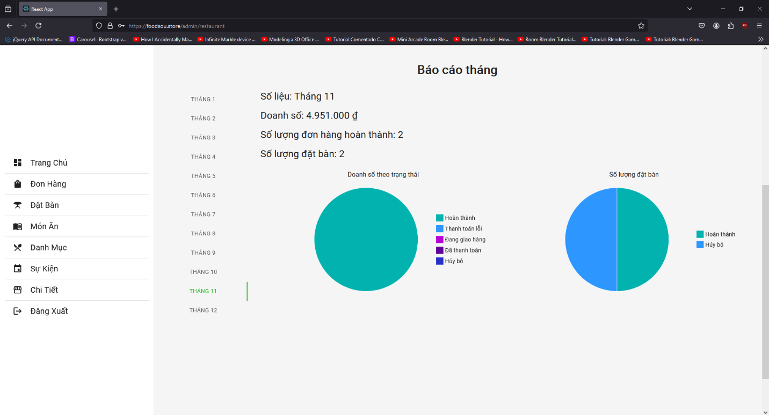

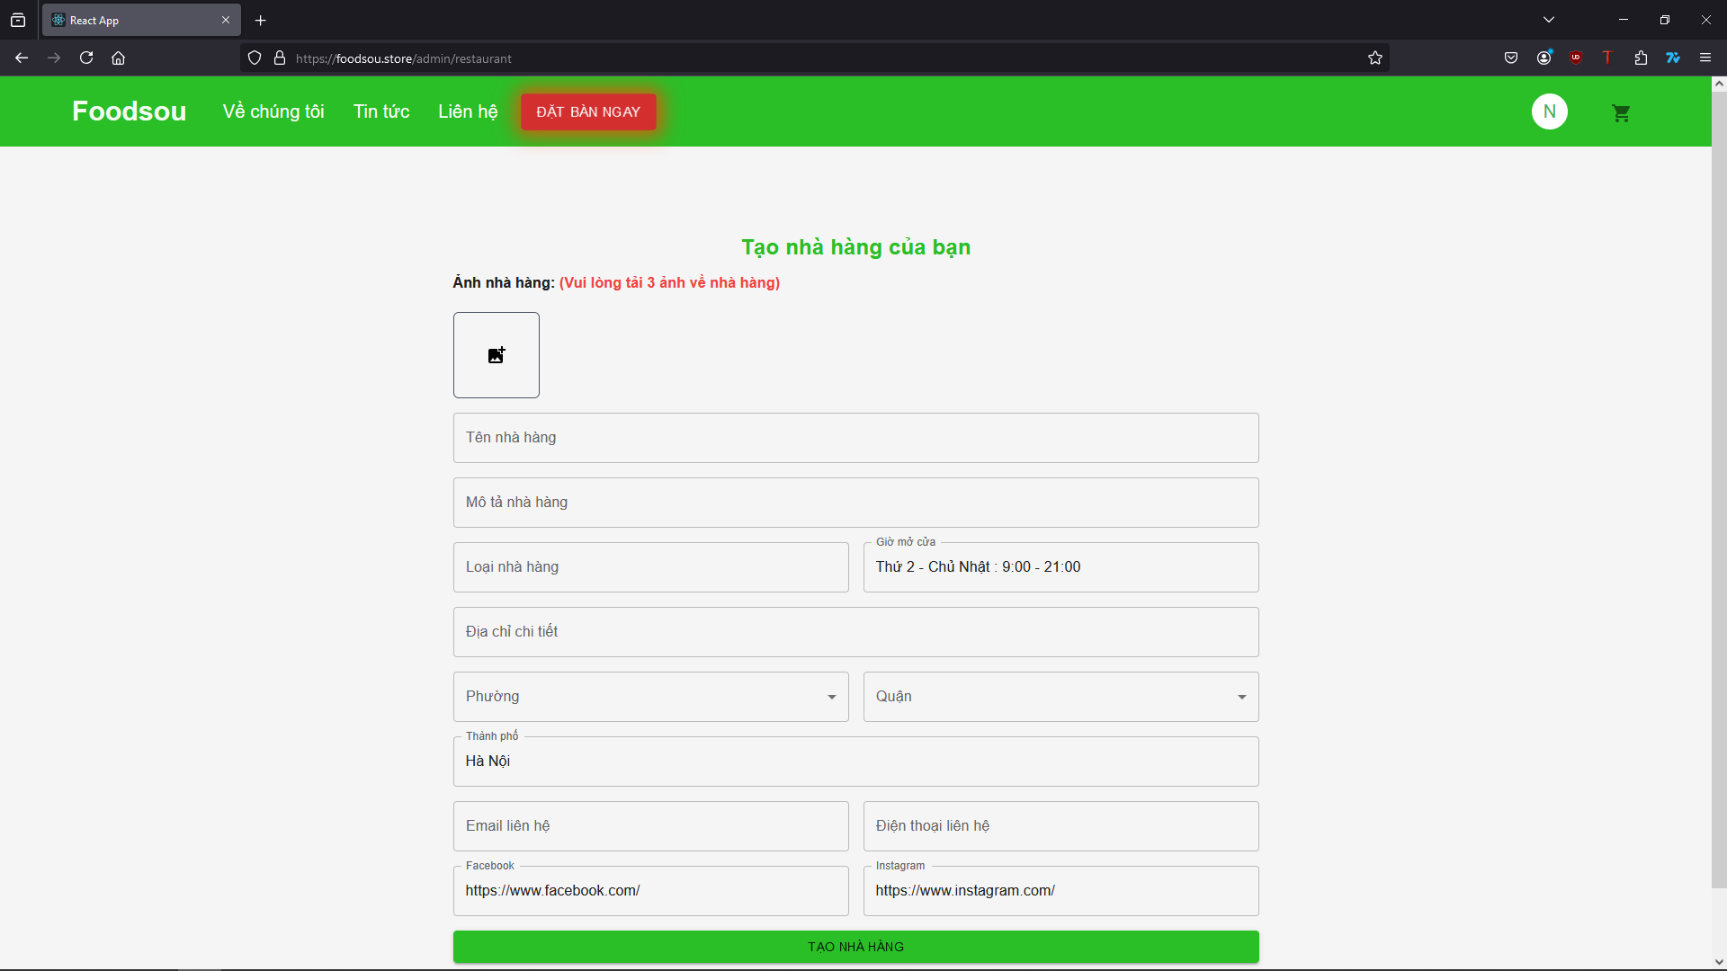

Admin can add restaurant with detail information, create restaurant menu with category for items of the menu.

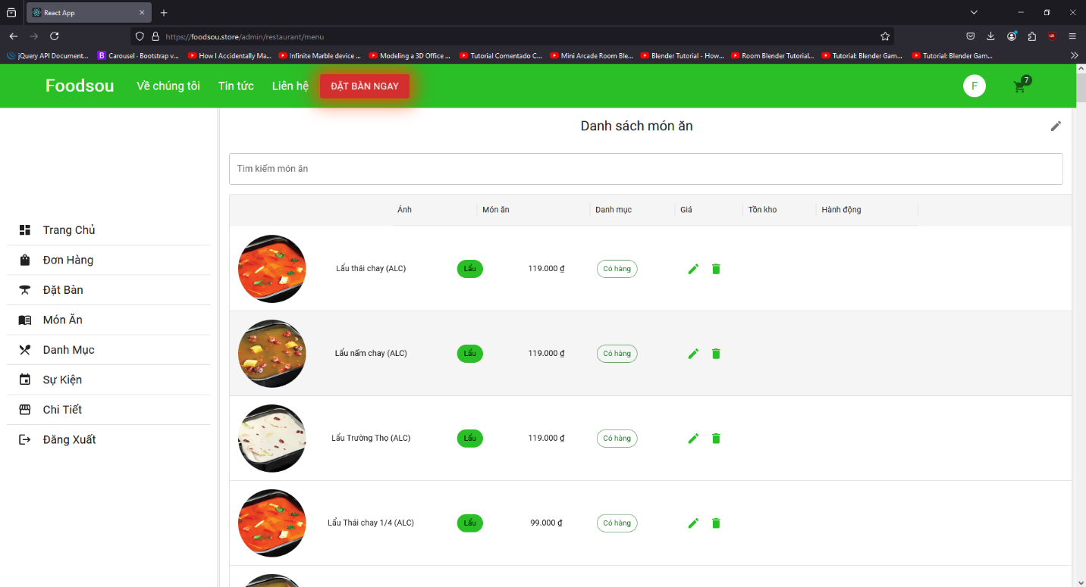

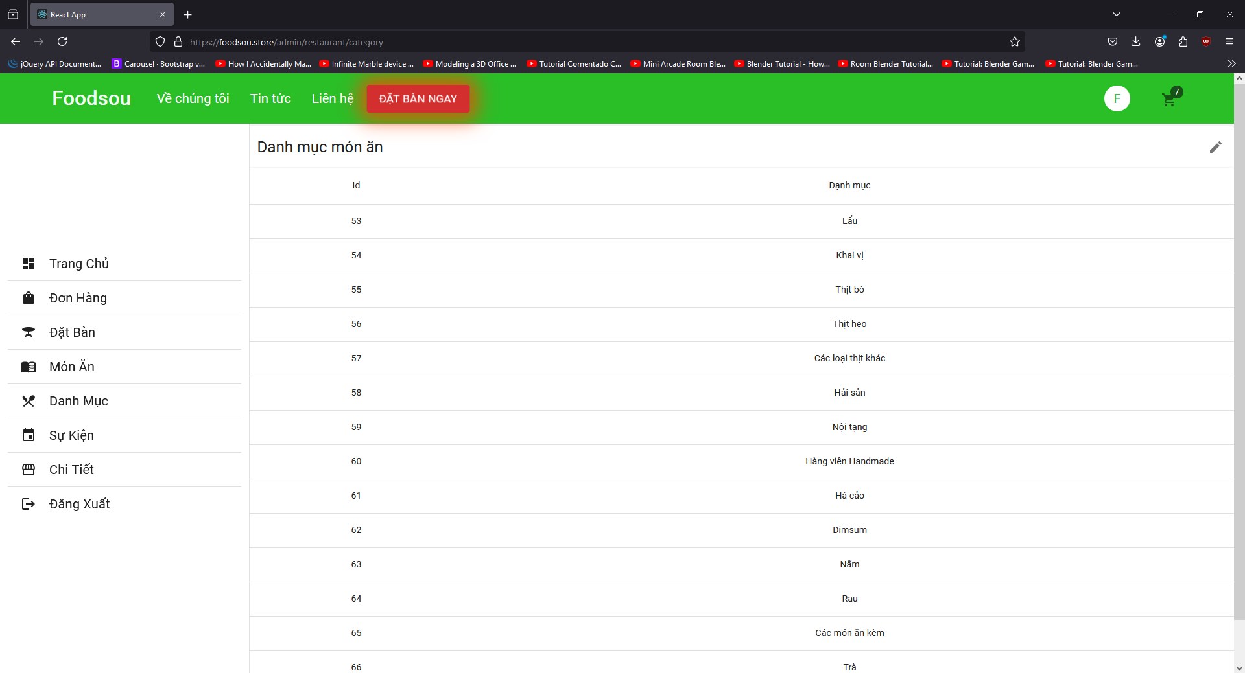

Admin can check the customer order and change the order status base on progress.

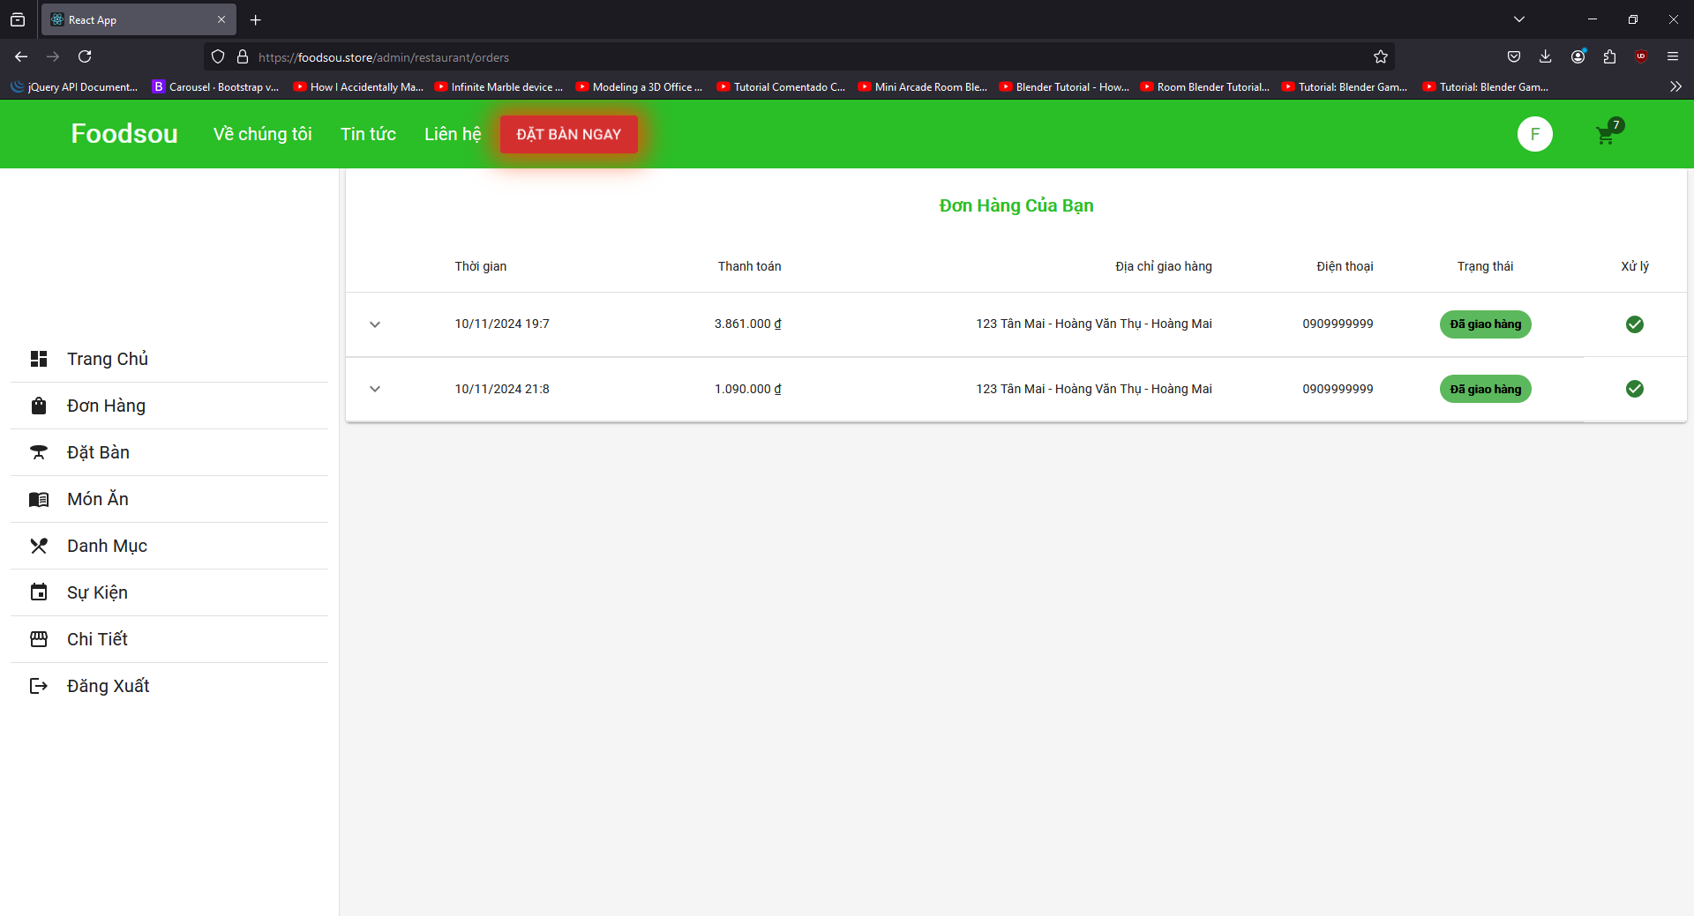

Admin can also check the customer booking table information and contact them to confirm the information.

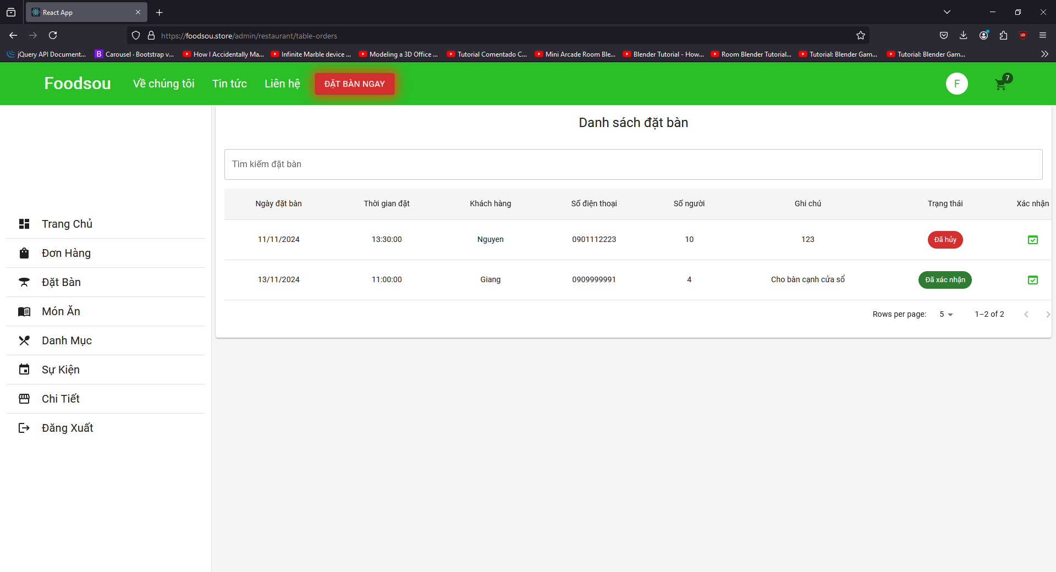

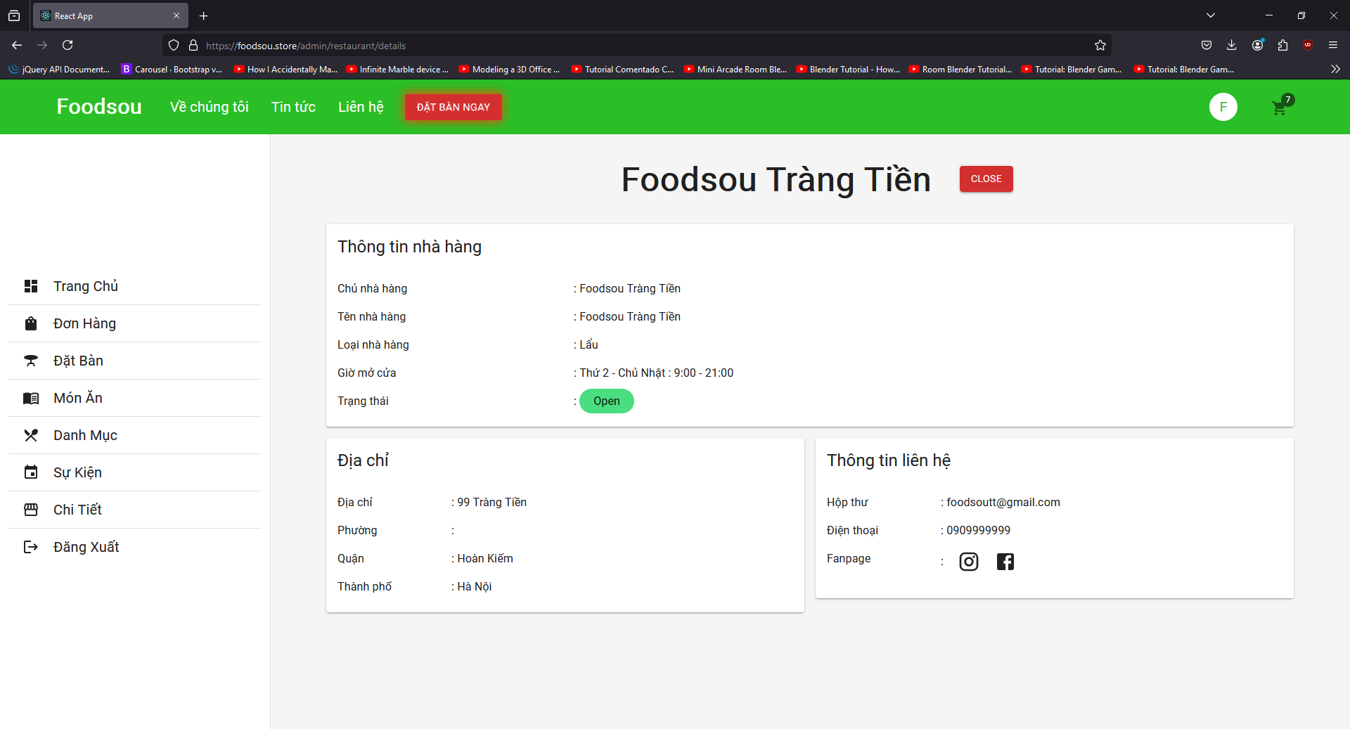

## **MOBILE APPLICATION**

User open “FoodSou” app on smart phone.

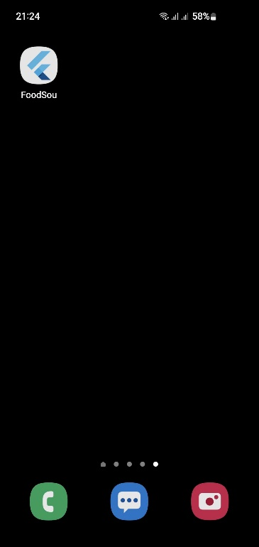

The App has a welcome screen, user press “Get started” to continue.

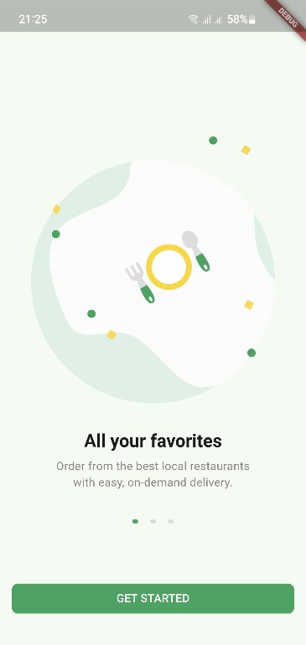 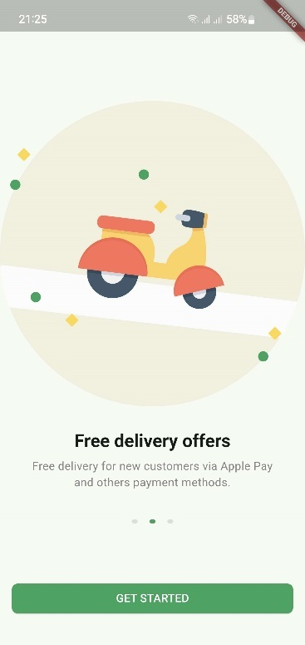

New User need to Sign Up for first time but if User already has an account created on the Website then just need to use that account to Sign In. User can use the account created in App to Sign In the Website. Just need 1 account for everything. Account created in App has customer role by default.

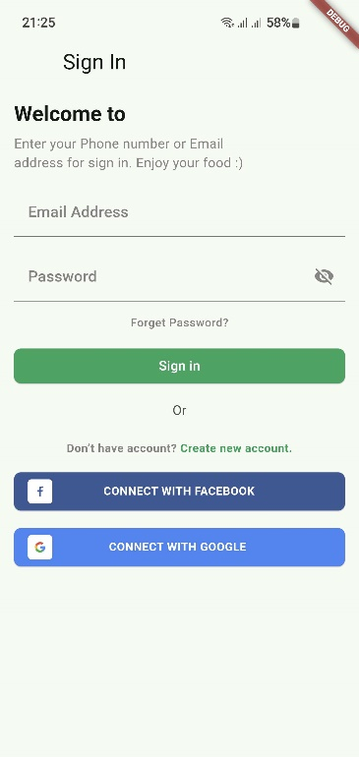 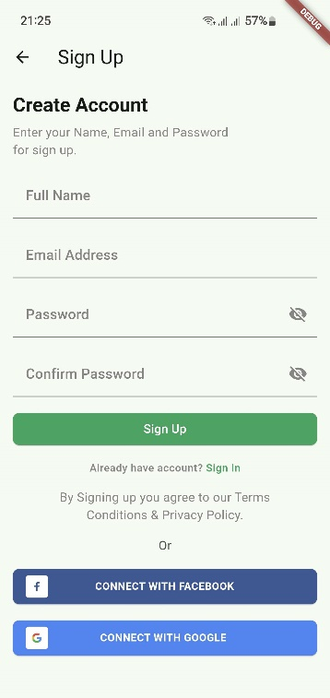

After Signed In, User can set up the address for delivery or find the nearest restaurant.

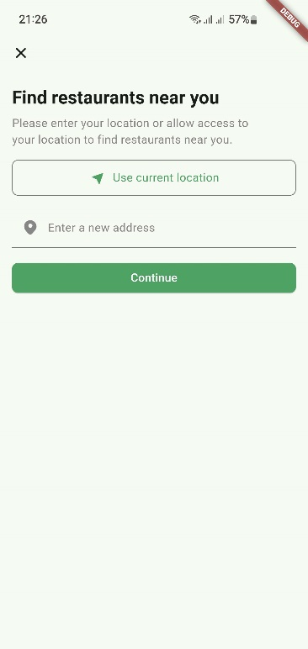

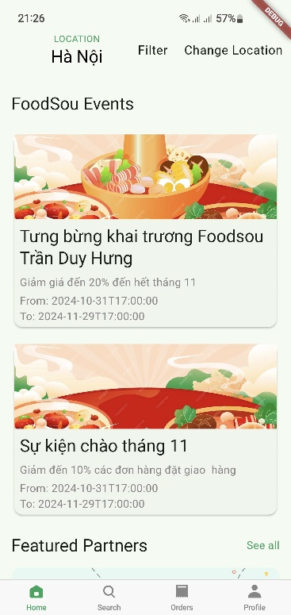 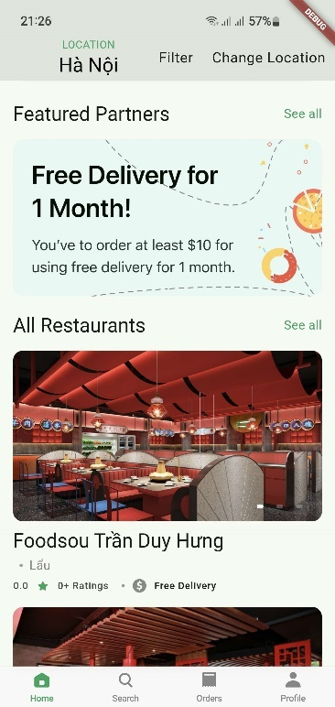

Customer can swiping the home screen to see the events and all restaurant list or search for a restaurant by press “Search” on the navigation bar below.

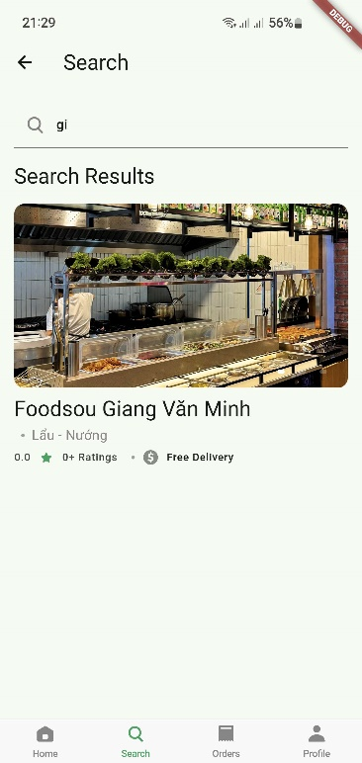

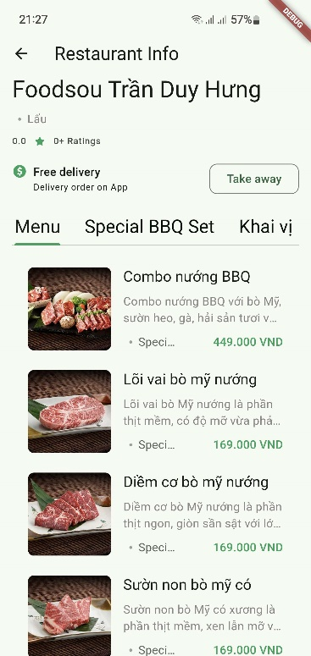 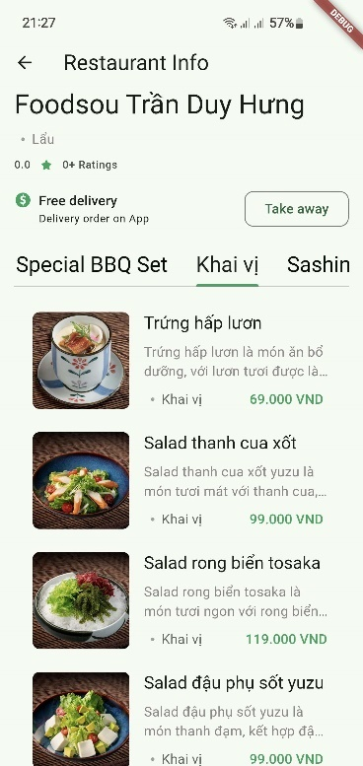

After choose the restaurant, User can see the restaurant information with the menu and the category of the food. Press on to see the item detail and add to cart if they like.

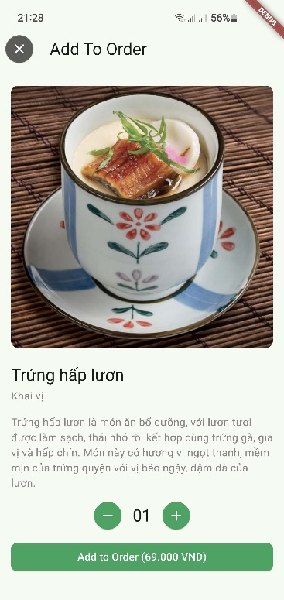

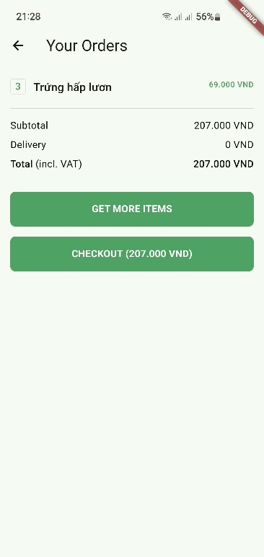

When ready to check out, press on “Check out” to get to the payment screen and pay for the order. After User confirmed order or paid for the order, Admin will see the Customer order on the admin site then they can progress the order.

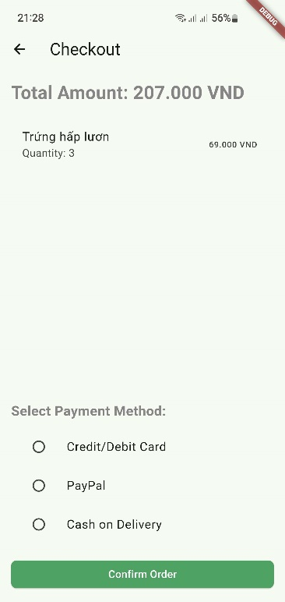 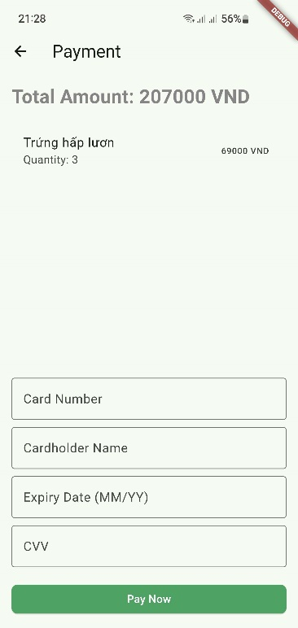

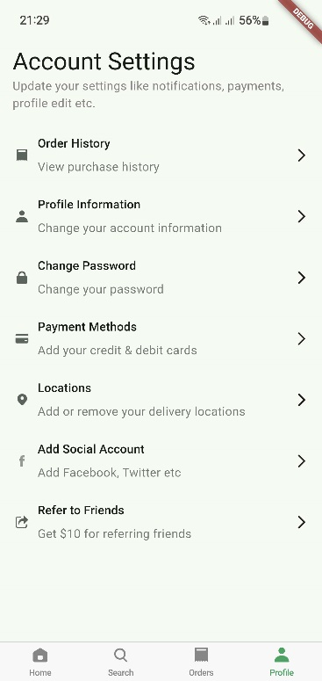

Press on “Profile” on the navigation bar, User can see the Profile detail information or check for their order history, etc.

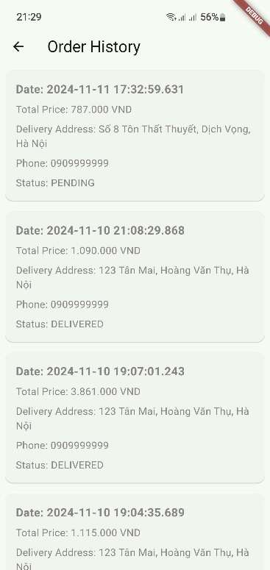 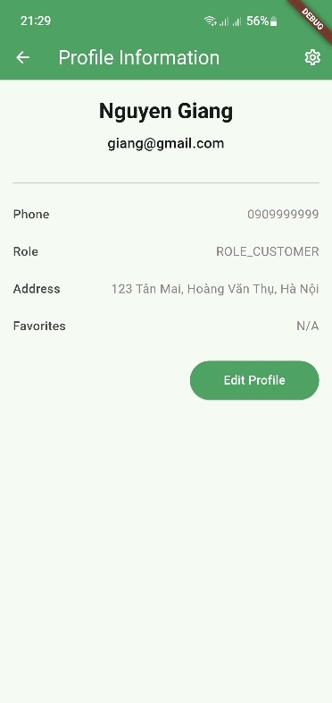

# Developer’s Guide

* 1. **Back-end Java**

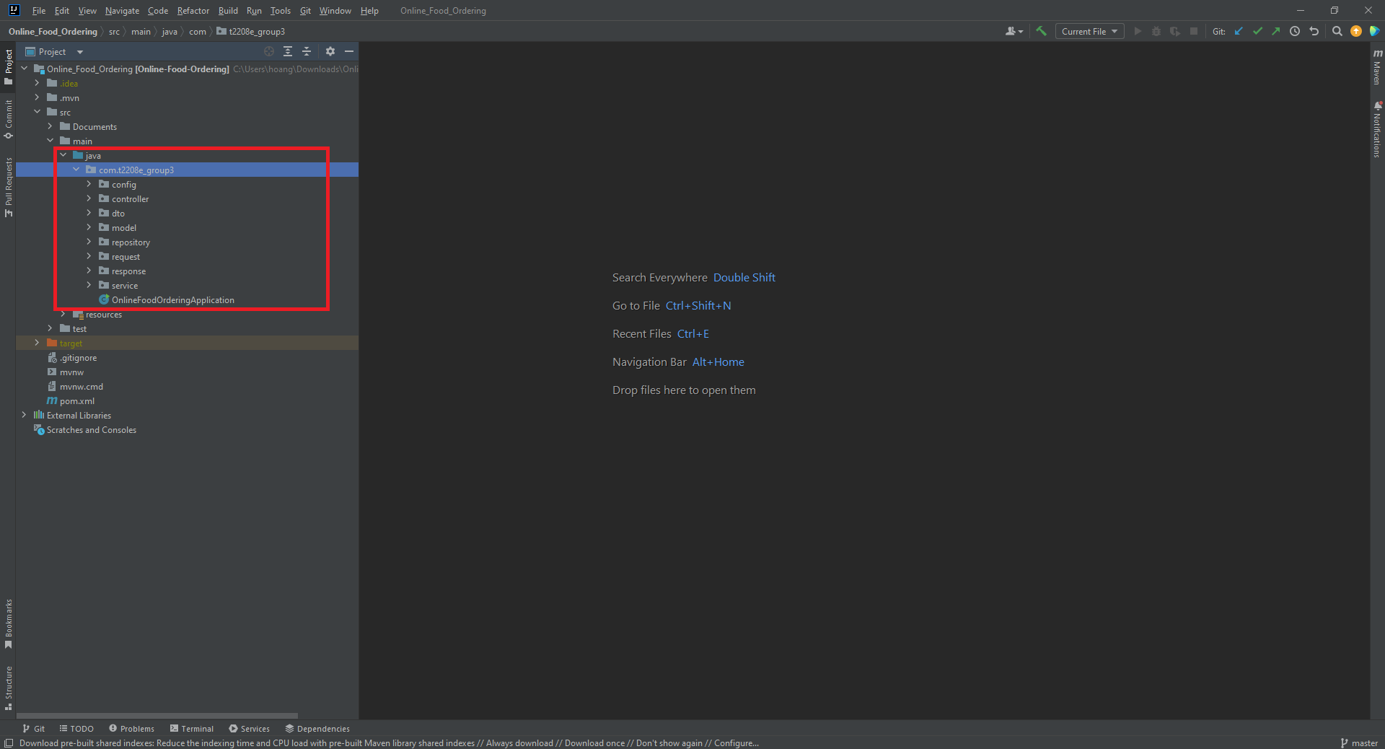

**Project Component Overview**

**1. Config**

* **Purpose**: Contains configuration settings for the application.
* **Responsibilities**:
  + Manages application-wide settings (e.g., database connection strings, API keys).
  + Provides environment-specific configurations (e.g., development, testing, production).
  + Ensures easy access to configuration values throughout the application.

**2. Controller**

* **Purpose**: Acts as the intermediary between the user interface and the application logic.
* **Responsibilities**:
  + Handles incoming requests from clients (e.g., web browsers, mobile apps).
  + Processes requests, invokes services, and returns appropriate responses.
  + Manages user input and output, ensuring proper data flow.

**3. DTO (Data Transfer Object)**

* **Purpose**: Serves as a data container for transferring data between layers of the application.
* **Responsibilities**:
  + Encapsulates data to be sent over the network, minimizing the amount of data transferred.
  + Reduces coupling between different parts of the application by providing a simplified data structure.
  + Helps in validating data before it reaches the model or service layers.

**4. Model**

* **Purpose**: Represents the core data structures of the application.
* **Responsibilities**:
  + Defines the data schema and relationships for the application’s entities (e.g., User, Product).
  + Contains business logic related to the entity (e.g., validation rules).
  + Interacts with the database through the repository layer.

**5. Repository**

* **Purpose**: Manages data access and persistence.
* **Responsibilities**:
  + Provides an abstraction layer for database operations (CRUD: Create, Read, Update, Delete).
  + Encapsulates database queries and operations, promoting separation of concerns.
  + Facilitates testing by allowing the use of mock repositories.

**6. Request**

* **Purpose**: Represents the structure of incoming requests to the application.
* **Responsibilities**:
  + Defines the expected format and content of requests (e.g., parameters, headers).
  + Validates incoming data before processing in the controller or service.
  + Provides a consistent way to handle request payloads.

**7. Response**

* **Purpose**: Represents the structure of outgoing responses from the application.
* **Responsibilities**:
  + Formats the data to be sent back to the client (e.g., JSON, XML).
  + Includes metadata (e.g., status codes, messages) to inform the client about the request's outcome.
  + Ensures consistent response structures across different endpoints.

**8. Service**

* **Purpose**: Contains the business logic of the application.
* **Responsibilities**:
  + Processes data received from the controller and interacts with the repository for data access.
  + Implements complex operations and workflows that involve multiple models or repositories.
  + Ensures that business rules are enforced throughout the application.
  1. **Front-end ReactJS**

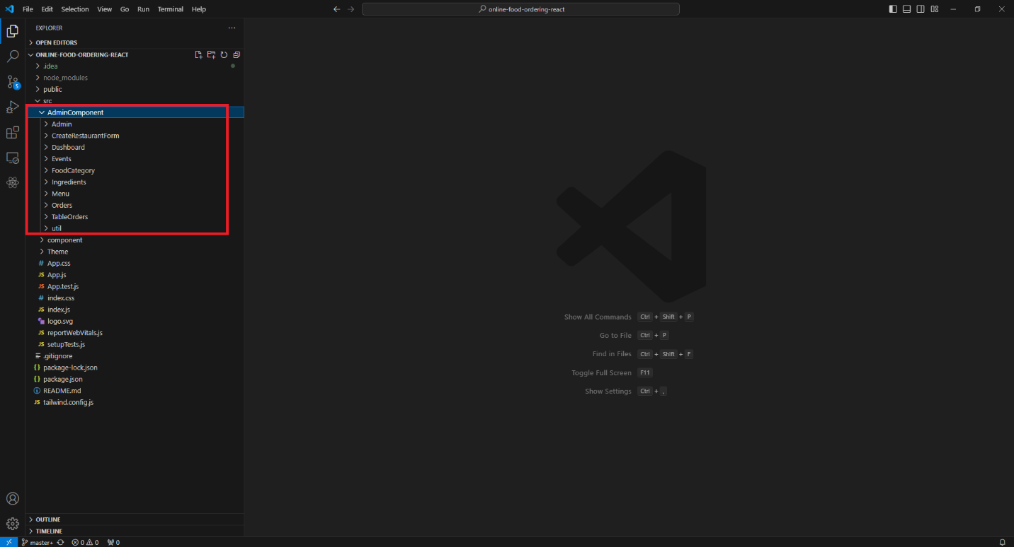

**AdminComponent**: This represents a specific part of your application that manages administrative functionalities. It includes features such as user management, content moderation, or settings configuration. Typically, this component would be responsible for rendering the admin interface and handling related logic.

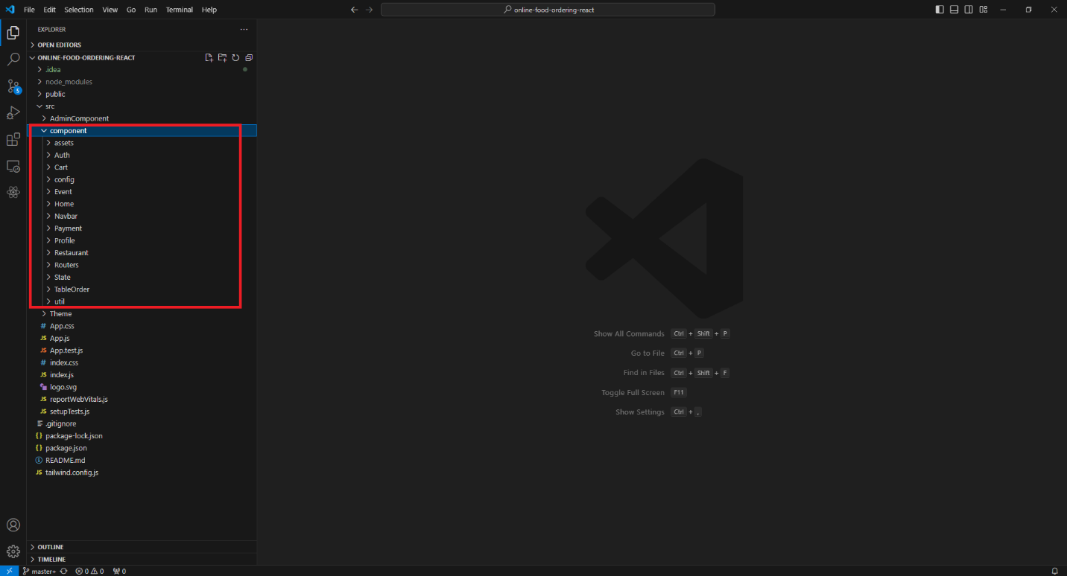

**Component**: Component refers to a reusable piece of UI that encapsulates its own structure, styling, and behavior. Components can be functional or class-based, and they help in structuring the application by breaking it down into manageable parts.

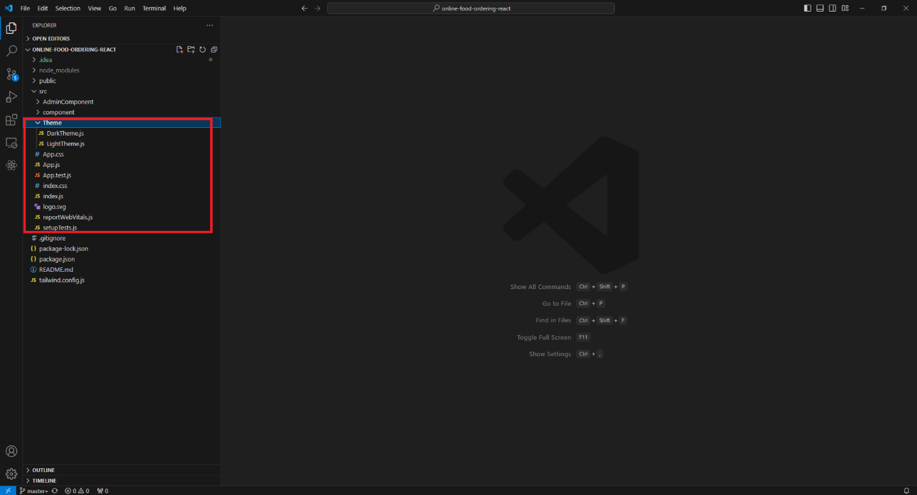

**Theme**: This typically refers to the styling and visual presentation of the application. A "Theme" component or file would define colors, fonts, spacing, and other style-related aspects that can be applied throughout the application. It allows for consistent styling and may support features like dark mode or color schemes.

* 1. **Mobile App**

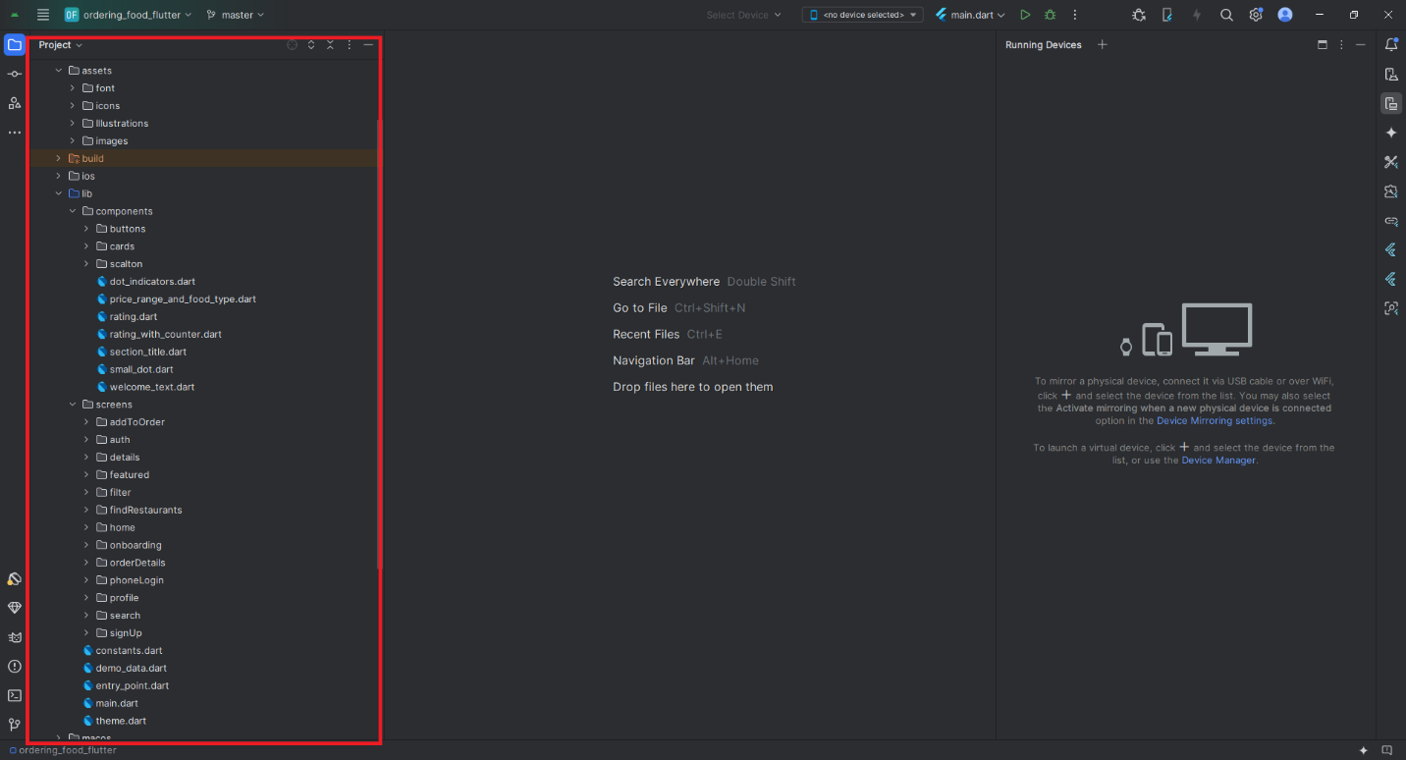

**Components**

* **Purpose**: This folder usually contains reusable UI elements or widgets that can be shared across different screens or parts of the application.
* **Examples**: Buttons, cards, input fields, and other custom widgets that encapsulate specific functionality or design.
* **Benefits**: By creating components, you promote code reusability and maintainability, allowing for easier updates and a consistent look and feel throughout the app.

**Screens**

* **Purpose**: This folder generally holds the main views or pages of the application, each representing a different screen in the user interface.
* **Examples**: Home screen, login screen, profile screen, settings screen, etc.
* **Benefits**: Organizing screens separately helps in managing the navigation structure of the app. Each screen can focus on its specific functionality while leveraging components for UI consistency.

**Summary**

* **Components**: Reusable widgets for UI consistency and reusability.
* **Screens**: Main application views that define the different pages users interact with.

This structure helps in maintaining a clean codebase and separates concerns effectively within a Flutter application.

# Acknowledgments

We would like to thank our Mentor Mr. Trịnh Ngọc Văn for his guiding role, wise counsel and vision in the creation of this website.

Many thanks as well to the team members, this website would not be able to be done without them, Nguyễn Bắc Giang, Nguyễn Hoàng Nam, Nguyễn Thanh Thủy, Trần Bùi Thành, Phạm Quốc Hoàng, Nguyễn Đặng Thái Sơn.

|  |  |  |
| --- | --- | --- |
|  | Team member | Task |
| 1 | Nguyễn Bắc Giang | BE, FE, Web Main theme, Features, Functions, Modules, Deploy to online server, Scripts, Database, Debug, Team Coordinator. |
| 2 | Nguyễn Thanh Thủy | Documentation, Use-case diagrams, database schema, diagrams for project, Testing, Products, Product details, Data. |
| 3 | Nguyễn Hoàng Nam | Mobile Application, Documentation, Guide, Video Demo, Slide, Contact us, Location, FAQ, Interface, Tester, Debug, Team Support. |
| 4 | Nguyễn Đặng Thái Sơn | Products, Product details, Data. |
| 5 | Trần Bùi Thành | Interface, About us, News, Contact us. |
| 6 | Phạm Quốc Hoàng | Products, Product details, Data. |